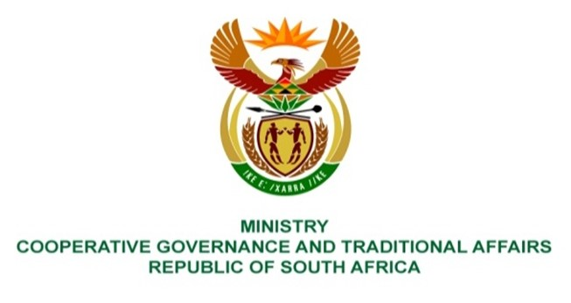

NATIONAL ASSEMBLY
QUESTION FOR WRITTEN REPLY

QUESTION NUMBER 1543
DATE OF PUBLICATION: 29 APRIL 2022

QUESTION:

1543. Mrs M R Mohlala (EFF) to ask the Minister of Cooperative Governance and Traditional Affairs:
Noting how the floods in KwaZulu-Natal claimed the lives of more than 400 persons, what measures is her department putting in place with municipalities in order to better deal with the impact of severe weather conditions in future? NW1867E

REPLY:

The Department of Cooperative Governance (DCOG) will be strengthening the support to municipalities in the following:
- The development and implementation of disaster management plans as per Sections 38, 39, 52 and 53 of the Disaster Management Act 57 of 2002;
- The assessment of submitted disaster management plans to check amongst others the level of compliance with the Disaster Management Act as well as the alignment with the guidelines on “development and structure of a disaster management plan”.
- Whether these plans incorporate disaster risk reduction (DRR) and climate change adaptation measures for inclusion into municipal programmes and projects as required for by the priorities and targets of the Sendai Framework for Disaster Risk Reduction (2015-2030).
- Engagement sessions with municipalities and Provincial Disaster Management Centres within respective provinces to discuss the respective assessment feedbacks.
DCOG will continue to collaborate with the Department of Forestry, Fisheries and Environment (DFFE) in supporting the district municipalities to develop the district climate change adaptation plans as well as providing capacity building programmes to the district municipalities on climate change with the view to facilitate mainstreaming of climate consideration into the municipal planning system. This will be done with the development of various tools such as Greenbook and Let-respond Toolkit which are aimed at offering the municipality with tools that could be used in planning for climate change response.
The above-mentioned inter-institutional support complements the current and planned work of the NDMC on disaster management planning and Impact Based Early Warning training with the South African Weather Service. The NDMC and the South African Weather Service will conduct Impact Based training for all districts in KZN for the 2022/23 financial year. The South African Weather Service and the NDMC will continue issuing of weekly Impact Based Early Warnings for approaching severe weather systems, especially in eastern coastal area. The NDMC will continue to distribute seasonal plans to all disaster management stakeholders highlighting hazard prone areas for medium term planning. and informed decision-making.

