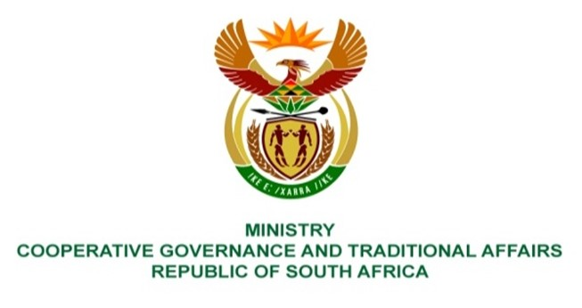

NATIONAL ASSEMBLY
QUESTIONS FOR WRITTEN REPLY

QUESTION NUMBER: PQ 1539
DATE OF PUBLICATION: 28 May 2021

QUESTION:

1539. Mr K Ceza (EFF) to ask the Minister of Cooperative Governance and Traditional Affairs:
What interventions does her department plan to put in place to regulate church attendance and other public gatherings, in light of the growing number of coronavirus cases in the Republic? NW1742E

REPLY:

The interventions put in place to regulate church attendance and other public gatherings in light of the growing number of coronavirus cases in the Republic, entails amongst others prohibiting gatherings, restricting the duration of gatherings or the number of people that may gather at any given time and reinforcing the health protocols and the social distancing measures that must be followed when gathering.

The National Coronavirus Command Council (NCCC) considered reports from the NATJOINTS and the Department of Health and recommended further restrictions to be put in place, in line with the Risk Adjusted Strategy for managing the pandemic. These measures are set out in Government Notice R.477 published in Government Gazette 44642 on 30 May 2021. It entails, amongst others, reducing the number of people that may attend indoor church and other public gatherings to 100 persons or less and outdoor gatherings to 250 persons or less. If the venue is too small to hold the prescribed number of persons observing a distance of one and a half meters from each other, then not more than 50 percent of the capacity of the venue may be used, subject to strict adherence to all health protocols and social distancing measures.

