FOR WRITTEN REPLY

NATIONAL ASSEMBLY
98/1/4f1(201600151}

DATG OF PUBLICATION iN INTE,R.§(AL QUE6T!Q QA GR 18 Y 2§18 LiNTGRNAL QUESTION PAPER MO 16-2016J
1639. Mr T R I\4a]oIa (DA) to ask the Minister of Police:
What number of (a) vehicles are available for visible policing wlth speclflc reference IO BOCtOF OllCfGg BI the Elsburg Police Station, (b) the apecBled vshkles have mileage of (I) 1-100 000 kms, {ii) 100 001-200 000 kma, (iil) 200 001-300 000 kms and (N) over 300 000 kms and (c) days In 2017 was each of the vehicles out of working order7

REPLY:
NW1B79E

Totsl vahk es available for Sector Policing |  |  |  |  |  |  | {b)(IV)
 | Number of  vehiclae (SAPS  numbers) | (c) days  out of working onJar for each vehlcle, ml 2017 | Number of  vertices (8AP8  numbers) | (c) daya  out of working older for aach vehlcB, In 2017 | Number of  vehicles (SAPS  numbers) | {c) daya  out of working older fbr  ah vohicla, In 2017 | Ntlmbar DI  vehblaa (9AP8  numbafe) | (c) deys  out of worklng order Ibr aach vehbB, In 2017
5 | BSSB94B | 73 | NII | NII | BSYS12B  BTJ065B | 151  68 | BSR210B  BSV284B | 70  b5

Originels‹‘ g» ad LiEuTz ANT OEnaeac PROVINCIAL COMMtb6lONER: QAUTENO DB DE LANGE
Date: 22 May 201B

Reply to queadon 1539 racommended/

T1 OUTH AFRICAN POLICE 8ERVICE

Reply to question 1539 appravsd/n
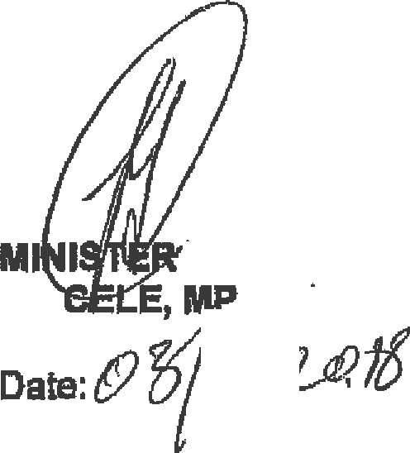

OF POLICE

