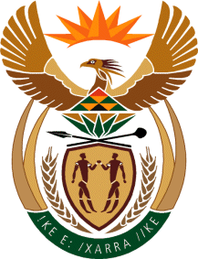

MINISTRY: COMMUNICATIONS
REPUBLIC OF SOUTH AFRICA
Private Bag X 745, Pretoria, 0001, Tel: +27 12 473 0164 Fax: +27 12 473 0585
Tshedimosetso House,1035 Francis Baard Street, Tshedimosetso House, Pretoria, 1000

NATIONAL ASSEMBLY
QUESTION FOR WRITTEN REPLY
QUESTION NUMBER: 1538
DATE OF PUBLICATION: MAY 2016

Ms J Edwards (DA) to ask the Minister of Communications:

(a) What amount did (i) her department and (ii) each entity reporting to her spend on advertising in the 2015-16 financial year and (b) how much has (i) her department and (ii) each entity reporting to her budgeted for advertising in the 2016-17 financial year? NW1709E

REPLY: THE MINISTER OF COMMUNICATIONS

(a) (i) The Department’s total spending on advertisement was R3.2 million in the 2015-16 financial year

(ii) Entities reporting to the Department spent the following amounts on advertising in the 2015-16 financial year:
SABC = R35 422 million
FPB = R332,684.00
ICASA = R5,339,278.00
Brand SA = R1,082,373.00
MDDA = R175,000.00

(b) (i) The Department’s advertising budget for the current financial year is R602,000.00

(ii) Entities reporting to the Department have budgeted the following amounts for advertising in the 2016-17 financial year:
SABC = R42 008 million
FPB = R1,109,064.00
ICASA = R4,233,655.00
Brand SA = R6 million
MDDA = R80 053.67

MR NN MUNZHELELE
DIRECTOR GENERAL [ACTING]
DEPARTMENT OF COMMUNICATIONS
DATE:

MS AF MUTHAMBI (MP)
MINISTER OF COMMUNICATIONS
DATE:

