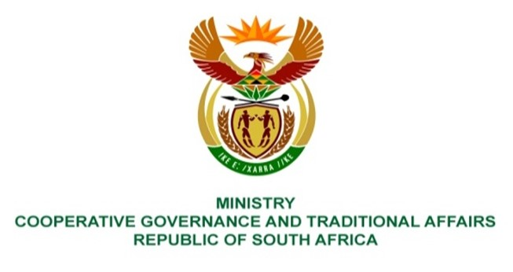

NATIONAL ASSEMBLY
QUESTION FOR WRITTEN REPLY

QUESTION NUMBER 1536
DATE OF PUBLICATION: 05 MAY 2023
1536. Ms H Ismail (DA) to ask the Minister of Cooperative Governance and Traditional Affairs:
Whether, given the persistent and detrimental impact of cable theft on municipalities across the Republic, which severely undermines service delivery, disrupts the lives of residents and places a significant financial burden on local governments, she will furnish Ms H Ismail with a comprehensive account of the (a) number of municipalities in each province that have reported cable theft at their respective police stations, (b) reasons for any discrepancies and/or lack of reporting and (c) total number of persons who have been apprehended for their involvement in cable theft thus far and (d) success of the current law enforcement strategies targeting the specified criminal activity? NW1779E

REPLY:
The South African Police Service deals with the criminal element of cable theft and vandalism. It is advised that the question be forwarded to the Ministry of Police, who can respond to it appropriately.
End.

