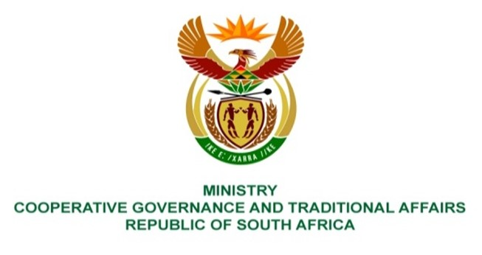

NATIONAL ASSEMBLY
QUESTION FOR WRITTEN REPLY

QUESTION NUMBER 1536
DATE OF PUBLICATION: 29 APRIL 2022

QUESTION:

1536. Mr K Ceza (EFF) to ask the Minister of Cooperative Governance and Traditional Affairs:
What remedial action has been taken by her department to assist local and provincial governments to strengthen the (a) Provincial Disaster Management Plan and (b) District Disaster Management Plan in order to better respond to the changing climate? NW1860E

REPLY:
(a) Provincial Disaster Management Plan (s)
It is encouraging to note that all provinces submitted their disaster management plans to the NDMC. Following submission of the plans by these organs of state, the NDMC assesses them to check amongst others the following:
- Level of compliance with the Disaster Management Act of 2002, other relevant legislative frameworks, policies and bylaws.
- Alignment with the guidelines on “development and structure of a disaster management plan”.
- Whether these plans incorporate disaster risk reduction (DRR) and climate change adaptation measures for inclusion into sector programmes and projects as required for by the priorities and targets of the Sendai Framework for Disaster Risk Reduction (2015-2030).
The NDMC further provides written feedback as well as hold engagement sessions on this feedback with provinces through Provincial Disaster Management Centres (PDMCs) as the custodians of these plans.
(b) District Disaster Management Plan (s)
It is encouraging to note that 38 District Municipalities and 7 Metropolitan Municipalities submitted their disaster management plans to the NDMC. Following submission of the plans by these organs of state, the NDMC develops the “municipal support schedule” in line with the APP project to “provide support to a number of municipalities in priority disaster areas to prevent, prepare and mitigate disaster risks through implementation of applicable disaster management plans”. In line with the developed Support Schedule, the NDMC assesses these identified disaster management plans to check amongst others the following:
- Level of compliance with the Disaster Management Act of 2002, other relevant legislative frameworks, policies and bylaws.
- Alignment with the guidelines on “development and structure of a disaster management plan”.
- Whether these plans incorporate disaster risk reduction (DRR) and climate change adaptation measures for inclusion into sector programmes and projects as required for by the priorities and targets of the Sendai Framework for Disaster Risk Reduction (2015-2030).
The NDMC further provides written feedback as well as hold engagement sessions with municipalities and PDMCs in the provinces within which municipalities whose disaster management plans were assessed belong. The NDMC further developed the “Support Plan” to assist and guide municipalities to address identified challenges prohibiting them to develop fit-for-purpose disaster management plans. Also, the NDMC developed “Guidelines on the integration of DRR, IDPs and DDM-One Plans of each District and Metropolitan Municipalities”. Both (Guidelines and the Support Plan) will be rolled out in all the provinces through the Provincial Disaster Management Centres (PDMC) for the duration of the current financial year. The DG of DCOG regularly writes letters to Accounting Officers within provinces and municipalities for non-submission of, as well as a reminder to update and review their plans that were previously developed and are outdated.
To complement all NDMC efforts in (a) and (b) above, the Department of Forestry, Fisheries and Environment (DFFE) supported all district municipalities to develop the district climate change adaptation plans. Furthermore, all provinces have been supported to develop their provincial climate change adaptation strategies. DFFE further provided capacity building programmes on climate change to all district municipalities with the view to facilitate mainstreaming of climate change considerations into the municipal planning system. This was done with the development of various tools such as Greenbook and Let-respond Toolkit which are aimed at offering municipalities with tools that could be used for climate change response planning. All the inter-institutional support complements the current and planned work of the NDMC on disaster management planning and Impact Based Early Warning training that the NDMC does with the South African Weather Service. In the 2022/23 financial year, the NDMC and SAWS will conduct Impact Based training for all districts in KZN. Both will continue to issue weekly Impact Based Early Warnings for the approaching severe weather systems, especially in the eastern coastal area. The NDMC Autumn and Winter seasonal plans highlighting hazard prone areas will also be distributed to all disaster management stakeholders in the province of KZN for the medium-term planning.

