FOR WRITTEN REPLY
ouaacox1sza

NATIONAL A66EMBLY

36/1/4/1(201600169}

DATE OF PUBMCATION IN INTERNAL QUESTION PAPGR: 18 MAY 201B (IMTMRNAL QMG6TION PAPER NO 16-201Bt
1M6. Mr G D Mataepe (DA) to aak the Mlnlstar ofPoIIce:
What number of (a) vehicles ara available fbr vblble policing w"ith specifk reference to eector policing at the Bedfoidviaw Police Station, (b) the specified vehicles have mileage of (I) 1-100 000 kms, (ii) 100 001-200 000 kms, (lil) 200 001-300 000 kms and (lv) over 300 000 kms and (c) days In 2017 was each of the vehiclse out of working order2
NW1078E
REPLY:

Bedfotdvlew  Total vehlclea available for Sactor Pollclng | 1-100 000kme
 | Number of  vahldw  (SAP6  numbers) | (c) days  out of worklng order for eed› vehicle, In 2017 | Number of  vehloles  (BAPS  numbers) | (c) days  out of worklhg order for  •ach vehlcle, In 2017 | Number  of vehklse (SAPS  numbers) | (c) days  DU( Df  working order for esch vohlde, in 2017 | Number  of vehicles (8APS  rumbere) | (c) daya  out of” worbi›g orger lot:”  esch .”.: vehlclé; ” In 2017. .
 | BVC218B | 1 | BTYd20B  BTL287B BTD30BB BBY719B | 1  16  10  80 | BGY310B | 50 | NII | Nli

Originel signad LIEUTENANT GENERAL PROVINCIAL COMlgl66lONER: GAUTEBG DB DE LANOE
Data: 22 May 2018

Reply to question 1536 ‹ecommended

ATI

OLE
GENERAL OUYH AFRICAN POLICE SERVICE

Reply to question 1536 approved/not approved

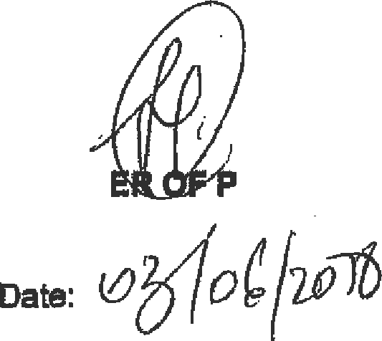
BH CELE, MP
ulNlsY
OLfCE

