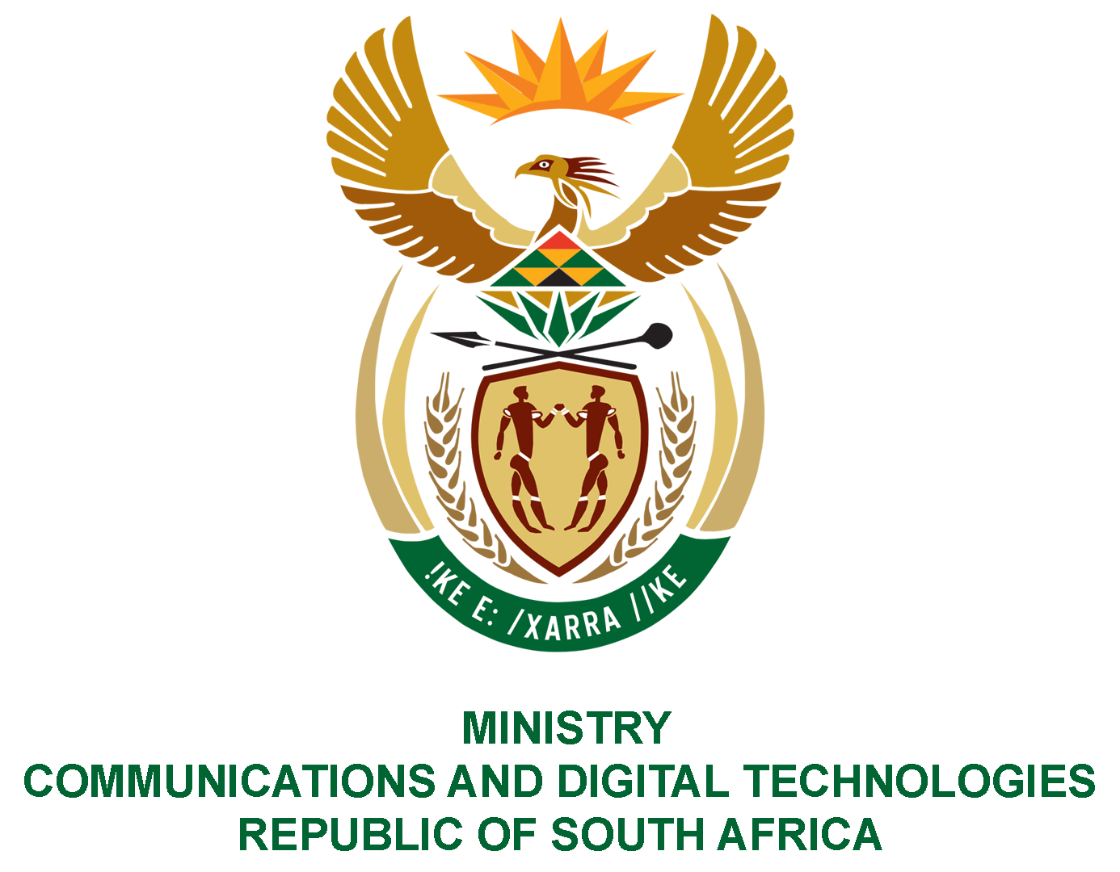

PARLIAMENT OF THE REPUBLIC OF SOUTH AFRICA

NATIONAL ASSEMBLY

WRITTEN REPLY

QUESTION: 1535

DATE OF PUBLICATION: 28 May 2021
QUESTION PAPER NO: 15

Mr E M Buthelezi (IFP) to ask the Minister of Communications and Digital Technologies:
Given the recent publication of the annual report of the SA Post Office’s financial results for the 2019-20 financial year, which shows that the Post Office is technically insolvent, how does she and/or her department intend to return the Post Office to solvency?
NW1738E

REPLY:
The SA Post Office has prioritised initiatives that focus on improving service delivery, revenue recovery and growth and cost reduction. The Department is concluding the procurement process to appoint a team of experts to develop a restructuring and turnaround plan for a sustainable post office of the future. The turnaround plan will inform the MTEF funding submission for the post office.

MS. STELLA NDABENI-ABRAHAMS, MP
MINISTER OF COMMUNICATIONS AND DIGITAL TECHNOLOGIES

