NATX)NALAS4ENBLY
FOR WRTTEN REPLY QUESTION 156b

DATE OF PUBLICAYtON IN IN¿¿s¿a¿,ousg«oN PAPER: ts uav z418
flNTERNAL QUESTION PAPER NO 16-2016)
What number of (a) vehicles are available for vialbla policing with specific reference to aector policing at the Edenvale Polica Station, (b) the specified vehicles have mileage of (g 1-100 000 kms, (II) 100 001-200 000 kme, (Ill 200 001-300 000 I‹ms and (iv) over 300 0D0 kms and (c) daya in 2017 waa each of me whk$ee out of
working order†

REPLY:
NW1675E

Totsl vehicles available for Sedor Policing
 | Numbsrd  vehiclaa (SAP6  numbers) | (c) days  out of working order for aach vehicle,  In 2017 | Number of  vehk›tas (SAPS  numbers) | (c) daya  out of working ordar for each vehlde,  in 2017 | Numbor  of vehicles (SAPS  numbers) | (o) days  out of working order for each vehicle,  in 2017 | I4umber of  vehicles (8AP8  numbara) | (c) dpye  out of worldn order for aach vehicle,  In 2017
3 | Nil | Nil | BTC840B BTJS51B | 95  14 | t4iI | NII | B9R044B | 44

Original s”pned LIEUTENANT GENERAL PROVINCIAL COMMISSIONER: OAUTENO

Date: 22 May 2018

Raply to queatlon J535 recommended

AL TOLE
Data: 26tf -(E-
Reply to question 1535 approval:Pn

GENERAL UTH AFRICAN POMCE SERVICE

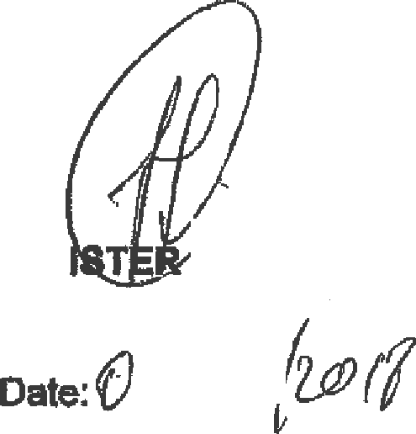
BH CEL
P

