

**MINISTRY**

**STATE SECURITY**

**REPUBLIC OF SOUTH AFRICA**

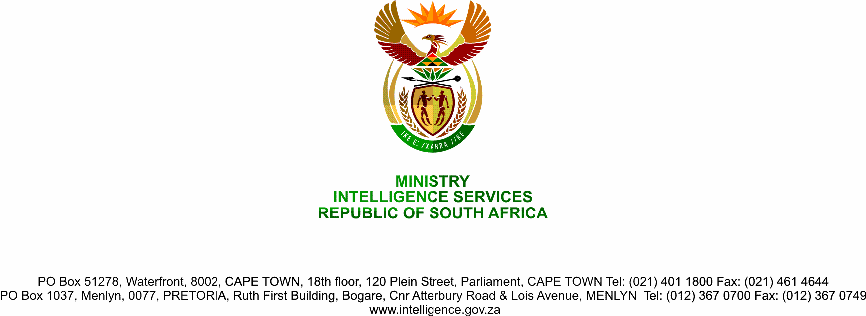

**NATIONAL ASSEMBLY**

**QUESTION FOR WRITTEN REPLY**

**QUESTION NO.: 1533**

**Dr M M Gondwe (DA) to ask the Minister of State Security:**

(1) What progress has her department made on the draft of the amendment of the General Intelligence Laws Amendment Bill [B25 of 2011], which will effectively disestablish the State Security Agency and break it up into two services, namely the domestic and foreign services;

(2) (a) on what date is the Bill likely to be introduced in the National Assembly and (b) what are the relevant details of the timelines in relation to the processes to be undertaken by his department and relevant government institutions before the introduction of the Bill in the National Assembly? NW1904E

**REPLY**

The Parliament Joint Standing Committee on Intelligence has scheduled a briefing by the State Security Agency on the General Intelligence Laws Amendment Bill (Gilab). This briefing will amongst others, provide progress on Gilab. Drafting of the General Intelligence Amendment Bill is taking place within context of ITT and implementation of the HLRP Recommendations. Strategic thrust of the ITT drafted Bill was re-creation of 1994/5 intelligence structures. This posed a significant challenge and threat to civilian intelligence. This Bill had to be revised to consider futurist configuration, which takes into consideration current, and emerging threats; Process of drafting Gilab including its buinsess case is affected by myriad factors including;

(b) Lockdowns aimed at containing spreed of Coronavirus COVID-19 pandemic;

(c) Consultation with the President on options for optimal configuration;

(d) Consultation with the National Treasury, Department of Public Service and Admnistration and JSC Cluster.

The Bill will be submitted to Parliament after approval by the Cabinet.