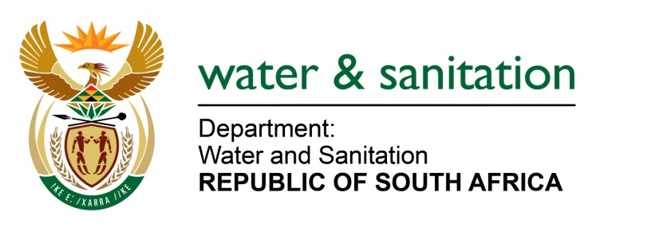

NATIONAL ASSEMBLY

FOR WRITTEN REPLY

QUESTION NO 1533

DATE OF PUBLICATION IN INTERNAL QUESTION PAPER: 20 MAY 2016
(INTERNAL QUESTION PAPER NO. 16)

1533. Ms K de Kock (DA) to ask the Minister of Water and Sanitation:
(1) Whether her department was approached by any political party for any form of funding (a) in the (i) 2013-14, (ii) 2014-15 and (iii) 2015-16 financial years and (b) since 1 April 2016; if so, what are the relevant details in each case;
(2) whether her department provided any form of funding to any political party (a) in the (i) 2013-14, (ii) 2014-15 and (iii) 2015-16 financial years and (b) since 1 April 2016; if not, what is the position in this regard; if so, what are the relevant details in each case? NW1704E
---00O00---
REPLY:
(1) My Department was not approached by any political party for any form of funding for the years in question.
(2) My Department did not provide any form of funding to any political party for the years in question.
---00O00---

