

**MINISTRY**

**STATE SECURITY**

**REPUBLIC OF SOUTH AFRICA**

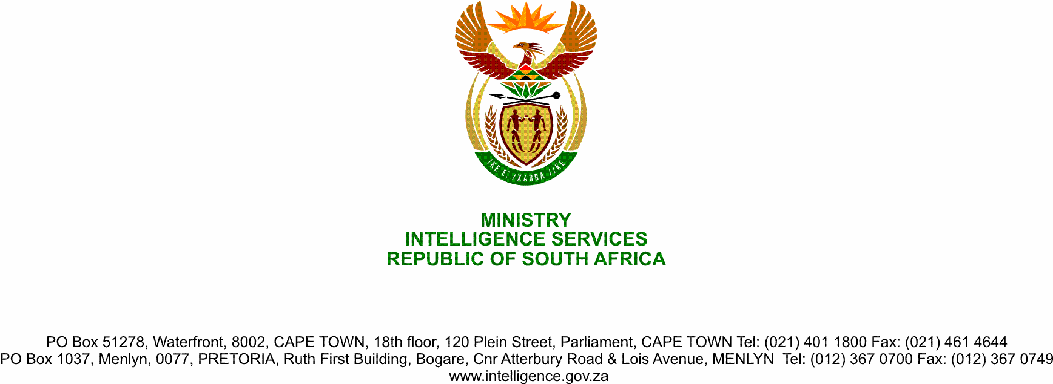

**NATIONAL ASSEMBLY**

**QUESTION FOR WRITTEN REPLY**

**QUESTION NO.: 1532.**

**Dr M M Gondwe (DA) to ask the Minister of State Security:**

(1) On what date will a permanent appointment be made for the position of Director-General of her department;

(2) has the contract of a certain person (details furnished)- *“Acting Director-General”)* been extended after it expired at the end of March 2020; if not, what is the position in this regard; if so, what are the relevant details;

(3) on what date will a permanent appointment be made for the position of Director: Foreign Branch;

(4) (a) what number of positions for deputy director-general within the State Security Agency (SSA) are currently occupied in an acting capacity and (b) on what date will permanent appointments be made for the specified positions;

(5) (a) what number of positions for General Manager within the SSA are currently occupied in an acting capacity and (b) on what date will permanent appointments be made for the specified positions?

NW1903E

**REPLY**

1. The matter on permanent appointment of the Director-General is a work in progress, details on the process including the date will be provided to the Parliament Joint Standing Committee on Intelligence.

2. Yes. The contract has been extended until 31 August 2020.

3. The permanent appointment for position of Director: Foreign Branch was made with commencement date of 1 July 2020

4 The number of Deputy Director-Generalpositions occupied in an acting capacity is four (4), permanent appointment to these positions is a workin progress.

5. The Number of General Manager positions occupied in an acting capacity is ten (10), permanent appointment to these positions is a work in progress.