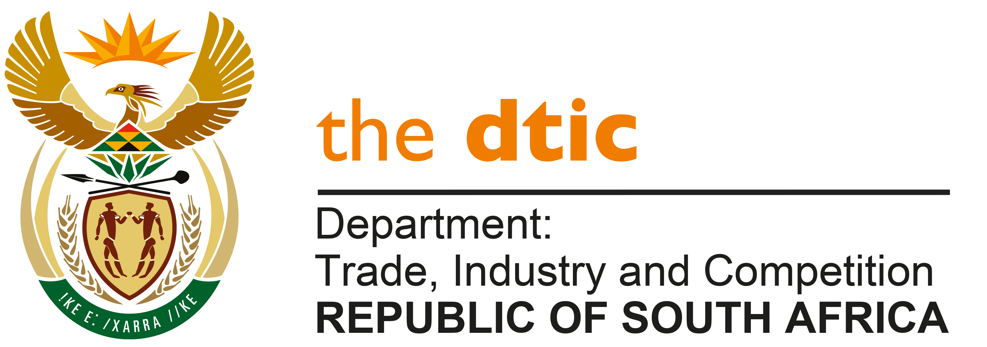

THE NATIONAL ASSEMBLY

QUESTION FOR WRITTEN REPLY

QUESTION NO. 1529
Mr M Waters (DA) to ask the Minister of Trade, Industry and Competition:

With reference to the reply of the Minister of Sports, Arts and Culture to question 197 on 27 May 2020, (a) for what specified purpose did the National Lottery allocate R4 million to the SA Sports Confederation and Olympic Committee (SASCOC) and (b) on what date (i) did (SASCOC) apply for the money and (ii) was the money transferred to SASCOC? NW1900E

REPLY:

I have been furnished with a reply to the question submitted, by MsThabangMampane, Commissioner of the National Lotteries Commission, which is reproduced below.
“Response from the National Lotteries Commission:
The South AfricanSports Confederation and Olympic Committee (SASCOC) applied for funding relating to Commonwealth Games in Glasgow on the 14th July 2014. The application was adjudicated on the 28th May 2015 and an amount of R 4 000 000.00 was granted. The approved funds were paid directly to SASCOC.”

-END-

