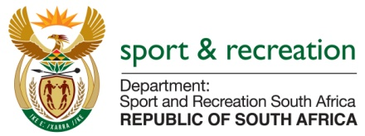

PARLIMENTARY QUESTION FOR THE MINISTER

QUESTION NUMBER 1527

1527. Dr M J Cardo (DA) to ask the Minister of Sport and Recreation:
(1) Whether his department was approached by any political party for any form of funding (a) in the (i) 2013-14, (ii) 2014-15 and (iii) 2015-16 financial years and (b) since 1 April 2016; if so, what are the relevant details in each case;
(2) whether his department provided any form of funding to any political party (a) in the (i) 2013-14, (ii) 2014-15 and (iii) 2015-16 financial years and (b) since 1 April 2016; if not, what is the position in this regard; if so, what are the relevant details in each case? NW1698E

REPLY
We are still going through our records to verify the information our archives.

