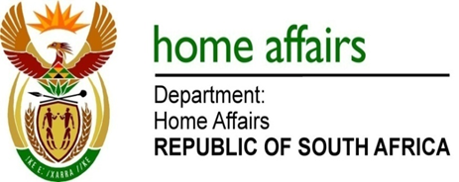

NATIONAL ASSEMBLY

QUESTION FOR WRITTEN REPLY

QUESTION NO. 1526

DATE OF PUBLICATION: Friday, 02 June 2017

INTERNAL QUESTION PAPER 20 OF 2017

1526. Mr A M Figlan (DA) to ask the Minister of Home Affairs:

Whether steps have been taken to address the limited information technology capabilities of her department to integrate its data platforms; if not, why not; if so, what are the relevant details? NW1727E

REPLY:

Yes, the National Population Register, National Immigration Information Systems and HANIS (Biometrics system) are in the process of being converted to a single National Identity System (NIS). The completion of the NIS is projected to be in FY 2019/20.

