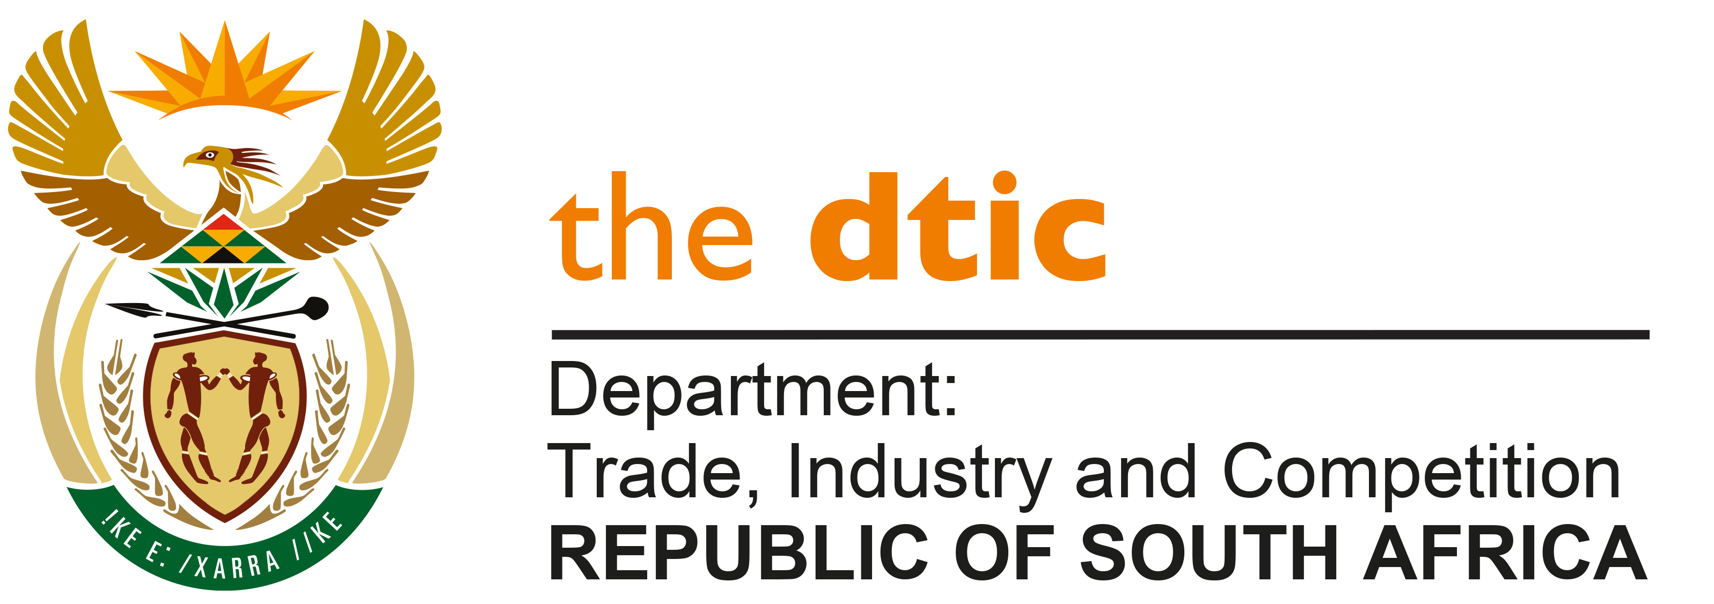

THE NATIONAL ASSEMBLY

QUESTION FOR WRITTEN REPLY

QUESTION NO. 1524

Mr M J Cuthbert (DA) to ask the Minister of Trade, Industry and Competition:

Whether, with reference to his reply to question 277 on 8 March 2023, he has found that the (a) Protocol on Intellectual Property Rights, which was formally reported at the African Union Assembly during February 2023 and (b) final agreement reached at the World Trade Organisation on waivers and flexibilities relating to pandemic use of patented vaccines had an impact on the Draft Patents Bill; if not, what is the position in each case; if so, in what way will the specified instruments have an impact on the Bill?

NW1767E

REPLY:

The impact of the Protocol on Intellectual Property Rights and the agreement at the World Trade Organisation on waivers and flexibilities relating to pandemic use of patented vaccines are being considered. Should no changes be necessary, the Bill will be finalised for public consultation. Should changes be necessary, these will be effected prior to the release of the Bill.

-END-

