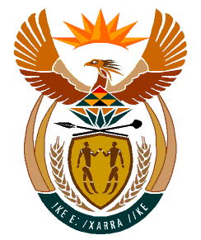

MINISTRY:
HUMAN SETTLEMENTS, WATER AND SANITATION
REPUBLIC OF SOUTH AFRICA

NATIONAL ASSEMBLY

QUESTION FOR WRITTEN REPLY

QUESTION NO.: 1524

DATE OF PUBLICATION: 15 NOVEMBER 2019

Ms E R J Spies (DA) to ask the Minister of Human Settlements, Water and Sanitation:
In view of the massive strain on key water and sanitation systems in the Republic, (a) which provinces have been the worst affected in their ability to deliver on their approved human settlement business plans and (b) what plans are in place to ensure provinces deliver on their approved human settlement business plans? NW2849E

REPLY:

(a) Consistent with the reply I submitted in respect Parliamentary Question 1523, I wish to reiterate that at present, no province has reported an inability to deliver on their approved human settlements business plans due to the massive strain on key water and sanitation systems.

(b) The Department will continue to exercise oversight on the performance of provinces for the commitments in their approved business plans. Moreover, we shall continue in our resolve to provide technical implementation support in pursuit of the targets set out in the business plans and Medium Term Strategic Framework.

