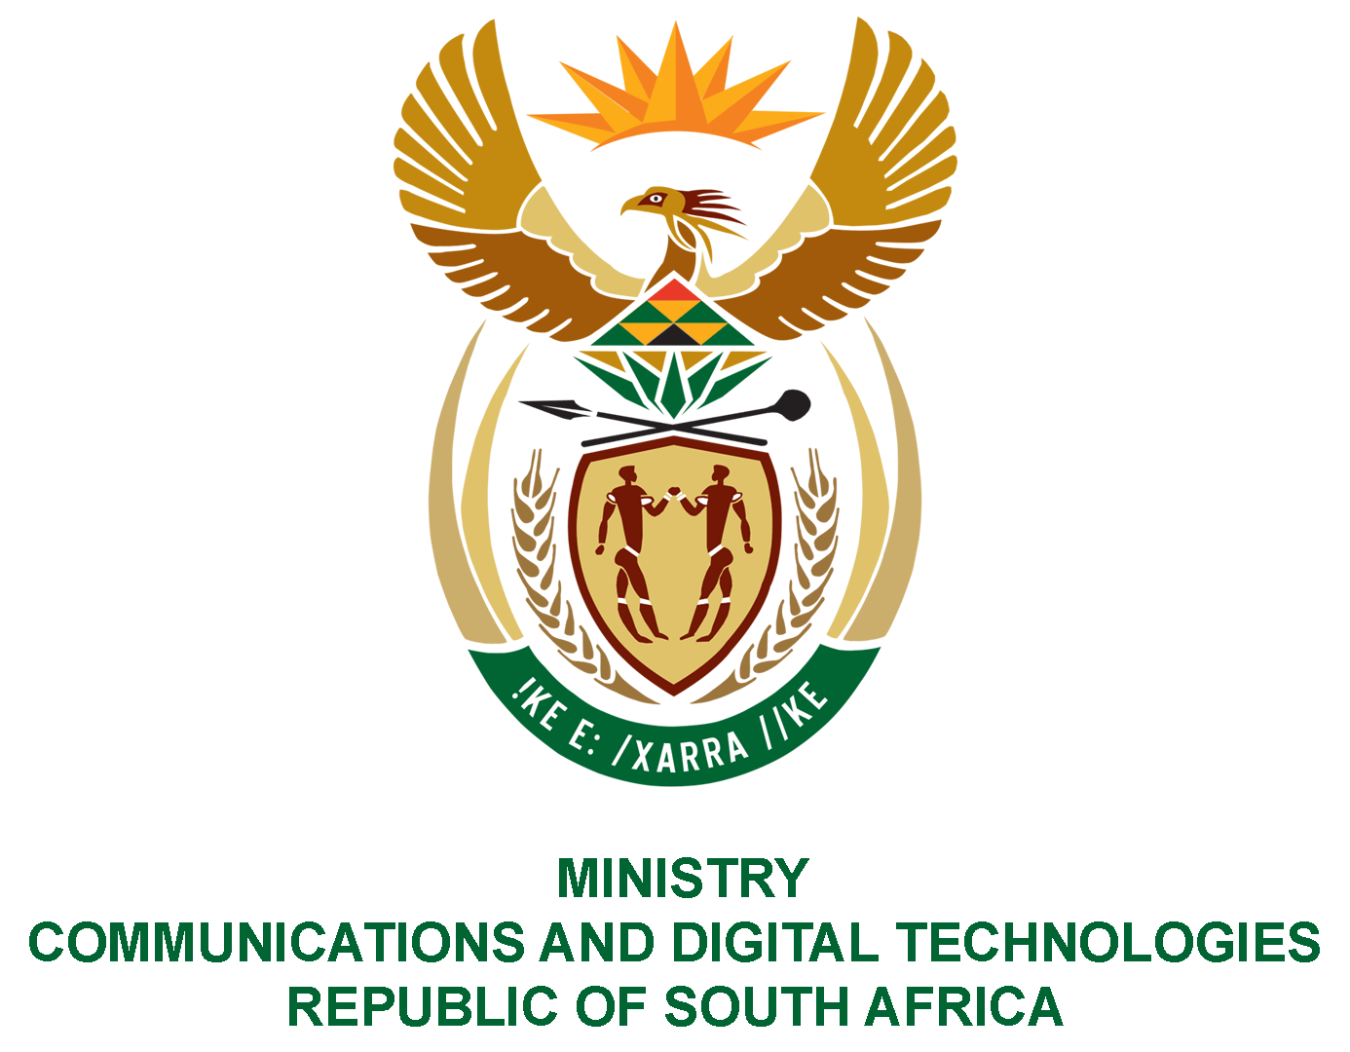

PARLIAMENT OF THE REPUBLIC OF SOUTH AFRICA

NATIONAL ASSEMBLY

WRITTEN REPLY

QUESTION: 152

DATE OF PUBLICATION: 10 FEBRUARY 2022
QUESTION PAPER NO: 01
Mr M Bagraim (DA) to ask the Minister of Communications and Digital Technologies:
Whether she and/or her department ever received correspondence from a certain political organisation (details furnished), via email, WhatsApp, hardcopy and/or in any other format of which the original file is dated June 2020; if not, what is the position in this regard; if so, (a) on what date was the specified correspondence received, (b) who was the sender of the correspondence and (c) what steps were taken by her department in this regard?
NW156E

REPLY:
No, the department did not receive such correspondence from the Political Party in question.

A rigorous procedure guided by Public Service prescripts is followed in the recruitment and appointment processes in the department.

