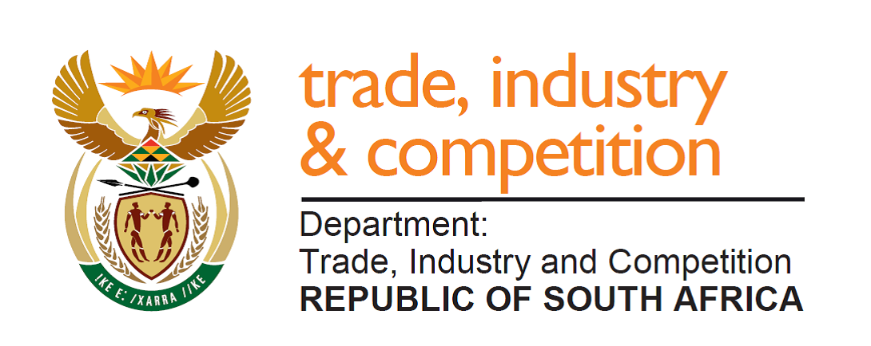

NATIONAL ASSEMBLY

WRITTEN REPLY

PARLIAMENTARY QUESTION 152

Mr D W Macpherson (DA) to ask the Minister of Trade and Industry:
By what date (a) does he envisage the forensic investigation into the conduct and payments to Ndzabandzaba Attorneys launched in 2018 will be completed and (b) will the outcomes of the forensic investigation be made public? NW173E

Reply

I am advised by the Economic Development Department that the report is expected to be completed within six weeks. The key findings and recommendations, together with any actions required from the Commission, will be made public.

-END-

