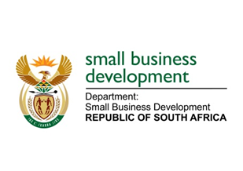
NATIONAL ASSEMBLY
QUESTION FOR WRITTEN REPLY
DUE TO PARLIAMENT: FRIDAY, 19 MAY 2013

“1519. Mr H C C Krüger (DA) to ask the Minister of Small Business Development:
How is (a) her department monitoring and evaluating the impact of the Small Enterprise Finance Agency and the Small Enterprise Development Agency’s services in rural communities and (b) it envisaged the information will be used to inform future policy and programme development around the area small business support?” NW1762E

REPLY:

- In relation to evaluation, I have been advised that the Department of Small Business Development (DSBD) periodically conducts different types of programme evaluations depending on the life cycle of an intervention/project or a programme. Just an example, in 2021/2022 financial year, the Spaza Shop Support Programme (SSSP) was subjected to a process evaluation. The purpose of the evaluation was to assess the effectiveness of the SSSP and to determine if the programme is achieving its intended objectives. The recommendations(information) derived from the evaluation were used to inform the programme review, enhance performance, and leaning. Furthermore, I have been advised that the department is finalising an impact evaluation of the Incubation Support Programme (ISP). The purpose of the impact evaluation is to determine how the beneficial impacts can be strengthened. The envisaged information/ outcomes from this evaluation will be used to inform current (review) and future policies including intervention design around small enterprise support.

- Entities and the DSBD’s Research Units use programme performance data to identify shortcoming in programme implementation and opportunities to enhance access to finance and financial inclusion. Entities’ programmes performance data was further used as an input in the formulation of the National Integrated Small Enterprise Development (NISED) Strategic Framework. The NISED Strategic Framework outlines government’s future policy direction for the SMME and Co-operatives sector.

