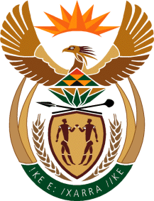
MINISTER IN THE PRESIDENCY: REPUBLIC OF SOUTH AFRICA
Tel: (012) 300 5200, Website: www.thepresidency.gov.za
NATIONAL ASSEMBLY
QUESTION FOR WRITTEN REPLY

QUESTION NUMBER 1518

1518. Mr D Bergman (DA) to ask the Minister in The Presidency:
(1) Whether his department was approached by any political party for any form of funding (a) in the (i) 2013-14, (ii) 2014-15 and (iii) 2015-16 financial years and (b) since 1 April 2016; if so, what are the relevant details in each case;
(2) whether his department provided any form of funding to any political party (a) in the (i) 2013-14, (ii) 2014-15 and (iii) 2015-16 financial years and (b) since 1 April 2016; if not, what is the position in this regard; if so, what are the relevant details in each case? NW1689E
REPLY:

No.

