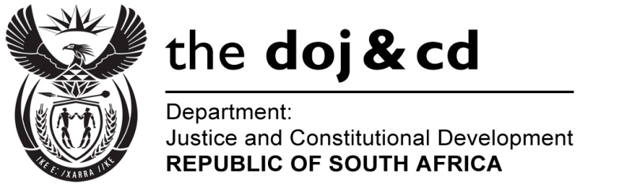

NATIONAL ASSEMBLY
QUESTION FOR WRITTEN REPLY
PARLIAMENTARY QUESTION NO: 1515
DATE OF QUESTION: 20 MAY 2016
DATE OF SUBMISSION: 3 JUNE 2016
1515. Mr L J Basson (DA) to ask the Minister of Justice and Correctional Services:
(1) Whether his department was approached by any political party for any form of funding (a) in the (i) 2013-14, (ii) 2014-15 and (iii) 2015-16 financial years and (b) since 1 April 2016; if so, what are the relevant details in each case;
(2) Whether his department provided any form of funding to any political party (a) in the (i) 2013-14, (ii) 2024-15 and (iii) 2015-16 financial years and (b) since 1 April 2016; if not, what is the position in this regard; if so, what are the relevant details in each case? NW1686E
REPLY:
- (a) (b) No

- (a) No

(b) The Department of Home Affairs is responsible for the administration of the
Public Funding of Represented Political Parties Act, 1997 (Act 103 of 1997)

- No political party has approached the Department of Correctional Services for any form of funding for the financial years in question. (a) for any of the periods mentioned in (i), (ii), and (iii).

(b) neither since 1 April 2016, in question.

- No funding has been provided to any political party in 2013-14, 2014-15 and 2015-16 financial years respectively.

(2)(b) None

