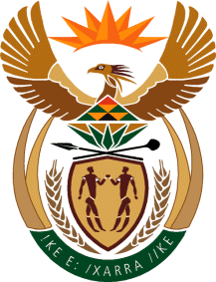

MINISTRY OF TOURISM
REPUBLIC OF SOUTH AFRICA

Private Bag X424, Pretoria, 0001, South Africa. Tel. (+27 12) 444 6780, Fax (+27 12) 444 7027
Private Bag X9154, Cape Town, 8000, South Africa. Tel. (+27 21) 469 5800, Fax: (+27 21) 465 3216

Ref: TM 2/1/1/10

QUESTION FOR WRITTEN REPLY:
Question Number: 1513
Date of Publication: 2 June 2017
NA IQP Number: 20
Date of reply: 22 June 2017

Prof N M Khubisa (NFP) to ask the Minister of Tourism:

(a) What is the total number of international visitors or tourists who visited the country in the 2016-2017 financial year and (b) whether this number represents an increase in the number of tourists visiting the country as compared to the 2015-2016 financial year? NW1689E

Reply:
- Total Number of international visitors to SA in 2016-2017 Financial Year

In the 2016-2017 financial year there were 9 945 373 international visitors to South Africa.

- Does this number represent an increase in comparison with 2015-2016 financial year

The total number of international visitors to South Africa in the 2016-2017 financial year represents a 6.6% increase from the 9 332 609 international visitors who visited South Africa in the 2015-2016 financial year.
Note: SA Tourism reports the number of international tourist arrivals by calendar year in line with Stats SA reporting and UNWTO. From 2017 SA Tourism will be reporting the number of international arrivals by both calendar year and financial year.

