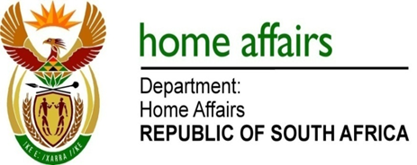

NATIONAL ASSEMBLY

QUESTION FOR WRITTEN REPLY

QUESTION NO. 1512

DATE OF PUBLICATION: Friday, 20 May 2016

INTERNAL QUESTION PAPER 16 OF 2016

1512. Mrs Z B N Balindlela (DA) to ask the Minister of Home Affairs:

(1) Whether his department was approached by any political party for any form of funding (a) in the (i) 2013-14, (ii) 2014-15 and (iii) 2015-16 financial years and (b) since 1 April 2016; if so, what are the relevant details in each case;
(2) whether his department provided any form of funding to any political party (a) in the (i) 2013-14, (ii) 2014-15 and (iii) 2015-16 financial years and (b) since 1 April 2016; if not, what is the position in this regard; if so, what are the relevant details in each case? NW1683E

REPLY:

(1-2) No.

