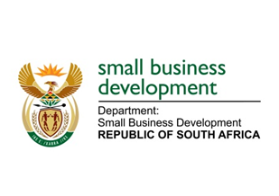
NATIONAL ASSEMBLY
QUESTION FOR WRITTEN REPLY
DUE TO PARLIAMENT: FRIDAY, 4 JUNE 2021

“1511. Prof C T Msimang (IFP) to ask the Minister of Small Business Development:
Whether her department has (a) made and/or (b) implemented any plans to assist small-, medium- and micro-enterprises to avert the cybersecurity risks they might be vulnerable to in the wake of the COVID-19 pandemic and the rise of cybercrimes; if not, why not; if so, what are the full relevant details?” NW1718E

_________________________________________________________________________________
REPLY:

The Department is well sensitised to the potential threats and risks posed to small enterprises. It is however important to note that the use of technology by small enterprises cannot be directly managed by the Department as this is an individual entity’s responsibility. Where the Department’s accountability lies is within the technology it exposes to small enterprises through its online platforms; and within this area, the Department has increased its own security measures and performs regular monitoring on potential breaches. Regular updates to the public via social media is maintained to inform of any risks or scams related to the Department.

_______________________________________________________________________________
RESPONSE RECOMMENDED BY:

_______________________
MR LINDOKUHLE MKHUMANE
DIRECTOR GENERAL: DEPARTMENT OF SMALL BUSINESS DEVELOPMENT
DATE:

______________________________________________________________________________
RESPONSE RECOMMENDED BY:

________________________
MS ROSEMARY CAPA, MP
DEPUTY MINISTER OF SMALL BUSINESS DEVELOPMENT
DATE:

_______________________________________________________________________________
RESPONSE APPROVED BY:

_________________________
MS KHUMBUDZO NTSHAVHENI, MP
MINISTER FOR SMALL BUSINESS DEVELOPMENT
DATE:

