PRIVATE BAG x 1000, PRETORIA, 0001, Tel: 082 677 2593

Minister
Memorandum from the Parliamentary Office

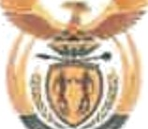
National Assembly question for written reply: 151

Mr S lophe
Actin › r liamentary Liaison Officer
Date:' q -y.

Supported /Net-6oggorted

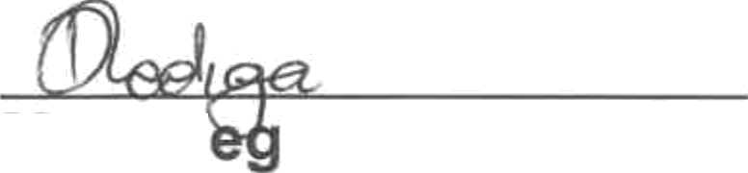
Ms D L wale
Chief Financial Officer Date: t?'§
Recommended / d

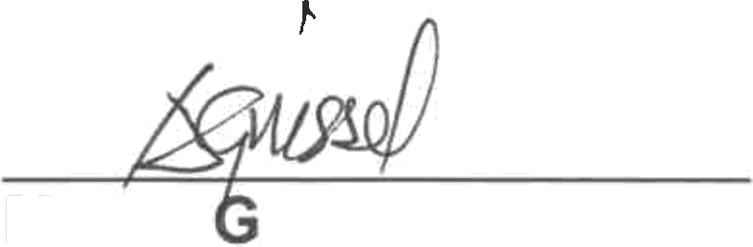Acting Director-General Date: g y

Ms AT riessel

NATIONAL ASSEMBLY QUESTION FOR WRITTEN REPLY
QUESTION NUMBER: 151
DATE OF PUBLICATION IN INTERNAL QUESTION PAPER: 07 FEBRUARY 2019
INTERNAL QUESTION PAPER NUMBER: 01 - 2019

Mr R T Hugo (DA) to ask the Minister of Women in The Presidency:
With reference to the reply of the Minister of Public Service and Administration to question 3797 on 21 December 2018, what was the total expenditure incurred by her OPice relating to the travel privileges contained in the 2007 Ministerial Handbook of former (a)(i) Ministers and (ii) their spouses, (b)(i) Deputy Ministers and
(ii) their spouses, (c) Ministers’ widows or widowers and (d) Deputy Ministers’ widows or widowers (i) in each of the past five financial years and (ii) since 1 April 2018?NW156E

Reply: Chapter 10 of the Ministerial Handbook states the following:
Parliamentary scheme
  - The travel privileges, administered and paid for by Parliament, of former Ministers/Deputy Ministers and their spouse come to into ePect on the first day following the date on which they relinquish their oFice, excluding the journeys made when vacating State-owned residences to the places where they intend to settle. (The Secretary of Parliament can be contacted for the details and administration relating to these privileges).
  - The costs of using VIP rooms at airports and any restaurants or bar services, as well as telephone calls, are payable by former Minister/ Deputy Minister themselves.
  - The Travel Privileges include:
    - Flights (Air Transport Tickets)
- Former Minister: Forty-eight (48) single domestic flights (business class) per annum.
- Former Deputy Ministers: Thirty six (36) single domestic flights (business class) per annum.
Of Spouses

MINISTRY IH THE PRESIDENCY: WOMEN REPUBLIC OF SOUTH AFRICA

  - Former Ministers: Twenty-four (24) single domestic flights (business class) per annum.
  - Former Deputy Ministers: Eighteen (18) single domestic flights ( business class)
  - Widow/Widower of former Minister’s/Deputy Minister: Twelve (12) single domestic flights per annum (business class).

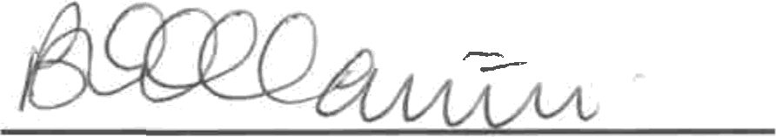
Approved by the Minist on
Date...I .I...”.....@.....'... ....

