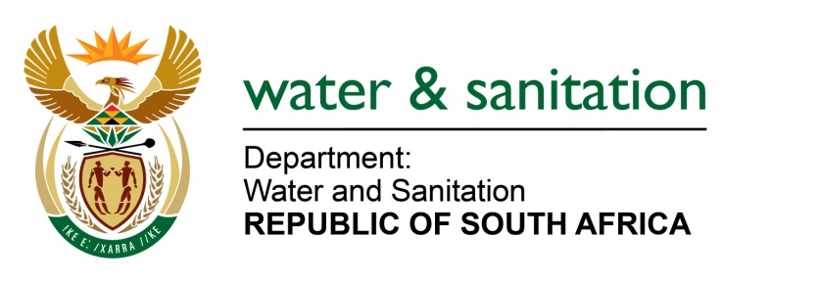

NATIONAL ASSEMBLY

FOR WRITTEN REPLY

QUESTION NO 1508

DATE OF PUBLICATION IN INTERNAL QUESTION PAPER: 29 APRIL 2022
(INTERNAL QUESTION PAPER NO. 15)

1508. Mr M G E Hendricks (Al Jamah-Ah) to ask the Minister of Water and Sanitation:

(1) Whether, given that the water infrastructure in KwaZulu-Natal in areas such as (a) Umdoni, (b) Umzinto, (c) Malangeni and (d) Port Shepstone have been in a dilapidated state well before the recent floods, he will indicate by which date the infrastructure in the specified areas will be improved; if not, why not; if so, by what date;

(2) whether any provisions are being made to assist the poor communities that are affected by the lack of and/or no access to drinking water; if not, why not; if so, what are the relevant details;

(3) whether he will establish an effective oversight committee to monitor repairs and/or the replacement of bulk water infrastructure; if not, why not; if so, what are the relevant details?

NW1830E
---00O00---

MINISTER OF WATER AND SANITATION

(1) The Ugu District Muniicpality is the Water Services Authority (WSA) for the aforementioned areas. All the water supply systems listed above have experienced water supply interruptions due to:
- Water demands exceeding the available supply. The schemes need to be upgraded to meet the growing demands.
- The aging pipe infrustructure, and mechincal and electrical componets of water treatment works and pumpstations. The corrective measures include the implementaion of a pipeline replacement programme under the Municipal Infrustructure Grant (MIG) and allocation of up to 10% of the MIG funding towards operations and maintainance.

The recent floods have severely impacted on water and sanitation services in the Ugu DM area and teams are currently assessing the damage to the infrustructure and working hard to restore water supply and recover the systems.
Prior to the floods, the Department of Water and Sanitation (DWS) had been assisting with the water services challenges that are being experienced in the Ugu DM. The DWS is a member of the Inter-Ministerial Task Team that has been established by the Premier of KwaZulu-Natal to determine the root causes of water supply interruptions in the various supply systems, develop implementable interventions, and monitor the progress made with implementation of the interventions.

The DWS is also a member of the Technical Task Team and the Water Supply Challenges WAR Room that is assisting the Ugu DM to implement immediate interventions to stabilise the supply systems and develop a turnaround strategy.

However, since the floods, support efforts have focused on restoring water and sanitation services to flood damaged areas and assessing the cost to restore the infrastructure. The DWS has also assisted the Ugu DM and the Provincial Disaster Mangement Centre with disaster relief funding applications.

(2) As part of the flood relief interventions, the DWS has also hired 20 additional water tankers to assist the Ugu DM to provide emergency relief across the District for 90 days. This will allow repairs to damaged infrastruture to be effected and the systems to be restored.

(3) As mentioned in 1 above, the DWS is part of the technical task team established by the Premier. This team is overseeing the interventions along with the Provincial Department of Cooperative Governance and Traditional Affairs and engineers from the Municipal Inftustructure Supprt Agency.

The DWS has also deployed a team of multidisciplinary engineers and technical experts to quantify and cost the flood damages.
---00O00---

