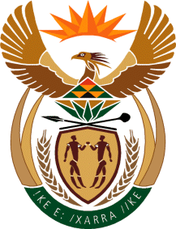

MINISTRY: COMMUNICATIONS
REPUBLIC OF SOUTH AFRICA
Private Bag X 745, Pretoria, 0001, Tel: +27 12 473 0164 Fax: +27 12 473 0585
Tshedimosetso House,1035 Francis Baard Street, Tshedimosetso House, Pretoria, 1000

NATIONAL ASSEMBLY
QUESTION FOR WRITTEN REPLY
QUESTION NUMBER: 1503
DATE OF PUBLICATION: MAY 2016

Mr D America (DA) to ask the Minister of Communications:

(1) Whether her department was approached by any political party for any form of funding (a) in the (i) 2013-14, (ii) 2014-15 and (iii) 2015-16 financial years and (b) since 1 April 2016; if so, what are the relevant details in each case; (2) whether her department provided any form of funding to any political party (a) in the (i) 2013-14, (ii) 2014-15 and (iii) 2015-16 financial years and (b) since 1 April 2016; if not, what is the position in this regard; if so, what are the relevant details in each case? NW1674E

REPLY: THE MINISTER OF COMMUNICATIONS

(1) (a)(i) N/A (DoC did not exist)
(ii) N/A (DoC did not exist)
(iii) No
(b) No
(2) No, the Department’s limited funds are geared towards its operations and strategic projects.

MR NN MUNZHELELE
DIRECTOR GENERAL [ACTING]
DEPARTMENT OF COMMUNICATIONS
DATE:

MS AF MUTHAMBI (MP)
MINISTER OF COMMUNICATIONS
DATE:

