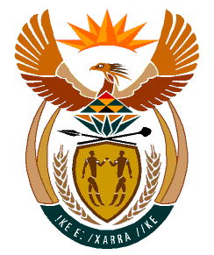

MINISTRY
HUMAN SETTLEMENTS
REPUBLIC OF SOUTH AFRICA

Private Bag X645, Pretoria, 0001. Tel: (012) 421 1309, Fax: (012) 341 8513

Private Bag X9029, Cape Town, 8000. Tel (021) 466 7603, Fax: (021) 466 3610

NATIONAL ASSEMBLY
QUESTION FOR WRITTEN REPLY
QUESTION NUMBER: PQ 1501 (NW1819E)
DATE OF PUBLICATION: 29 APRIL 2022

Mr. B N Herron (Good) to ask the Minister of Human Settlements:

With regard to the apartheid era migrant labour hostels, what (a) total number of privately-owned hostels (i) have been abandoned and/or (ii) are no longer managed and/or maintained by their private owners and (b) does her department intend to do with the privately-owned hostels?

REPLY
- Government has no legal authority/jurisdiction over privately owned hostels and as such information/statistics required is not held by any sphere of government, instead, the government’s authority is limited only in respect of public hostels which are owned by provincial human settlements departments or municipalities.

(b) The Department is currently consulting stakeholders to solicit inputs for the regulations that must inform norms and standards that will apply to privately and publicly-owned rental accommodation.

