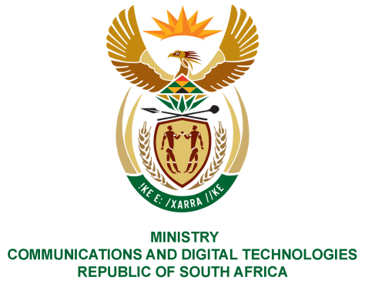

PARLIAMENT OF THE REPUBLIC OF SOUTH AFRICA

NATIONAL ASSEMBLY

WRITTEN REPLY

QUESTION NO: 1500

Mr C MacKenzie (DA) to ask the Minister of Communications:
- What spectrum bands have been allocated to the SA Broadcasting Corporation for broadcasting (a) television, (b) radio and (c) other services such as shortwave transmissions;
- (a) how much of the assigned spectrum is currently unused and (b) what is the list of the spectrum bands;
- whether any assigned spectrum is traded and/or leased to third parties; if not, what is the position in this regard; if so, (a) what is the list of the bands, (b) who have the bands been assigned to and (c) what are the respective terms and conditions?

REPLY
I have been advised by the Department as follows:
(1)&(2) The Independent Communications Authority of South Africa (ICASA) has assigned Radio Frequency Spectrum to the South African Broadcasting Corporation (SABC) for the purpose of providing both commercial and public sound and television broadcasting services. The details of the frequencies assigned to the SABC are provided in the table below. The table further outlines the frequencies that are currently being used as well as the number of frequencies unused:

Frequency Band | Broadcasting Service | Number of  Frequencies  Assigned | Number Frequencies Unused
470 -694  MHz | Terrestrial  Television  (SABC1, SABC2 and SABC3) | Digital Terrestrial Television  Multiplexer 1 (182 frequencies assigned) – 85% of capacity of  Multiplexer 1 | At least 75% of the useable frequencies in the broadcasting frequency band 470 to 694 MHz is normally unused due to the nature of the planning methodology for Broadcasting Services and is earmarked for the use of Television Whitespaces applications.
NB. 15% allocated to Community
Television
87.5 -108  MHz  (FM) | Sound | 792 frequencies  (21 stations) | 140 spare frequencies categorised for public sound broadcasting (earmarked for possible coverage expansion).
535.5 - 1606.5 kHz  ( MW/AM) | Sound | 2 frequencies  (2 stations) | 43 non categorised frequencies (can be used for public/community/commercial sound broadcasting with coordination with neighbouring and existing broadcasters in the band)

- In terms of the current regulatory regime, spectrum trading is not presently allowed in South Africa. Therefore, no frequency bands are leased to third parties.

MS. STELLA NDABENI-ABRAHAMS, MP
MINISTER OF COMMUNICATIONS AND DIGITAL TECHNOLOGIES

