FOR WRITTEN REPLY QUESTION 15

NATIONAL ASSEMBLY
36/1/4/1(201900013)

DATE OF PUBLICATION IN INTERNAL QUESTION PAPER: 7 FEBRUARY 2019 (INTERNAL QUESTION PAPER NO 1-2019)
15. Dr P J Groenewald (FF Plus) to ask the Minister of Police:
- In which number of murders committed (a) in the financial year (i) 2015-16, (ii) 2016-17 and (iii) 2017-18 and (b) since 1 April 2018 is the murder committed by using (aa) legal or licensed firearms, (ii) illegal or unlicensed firearms, (iii) knives and/or (iv) other sharp objects;

- whether he will make a statement on the matter?

REPLY:

(1)(a)(i)(ii)(iii)(b)(aa)(ii)(iii)(iv)

NW19E

Type of instrument”
2015/2016 2016/2017 2017/201B
1 April to 30
September 2018

Firearms | 5 417 | 5 857 | 6 640 | 3 622
 | 4 923 | 4 811 | 4 881
Other shar ob”ects | 2 005 | 2048 | 2 239 | 963

”The Crime Administration System (CAS) does not make provision for a distinction between a licensed or unlicensed firearm.

(2) The Minister will decide whether he wants to make a statement, in this regard.

Reply to question 15 recommended/not recommended

LIEUTENANT GENERAL EPUTY NATIONAL COMMISSIONER: MANAGEMENT ADVISORY SERVICES
SC MFAZI

Reply to question 15 recommended

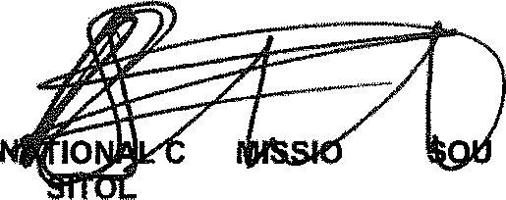
GENERAL
OM NER: TH AFRICAN POLICE SERVICE KJ E(SOEG)

Date: YOU -yz- ] §

Reply to question 15 approved/not approved
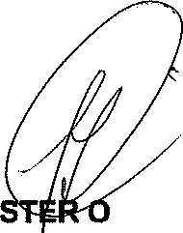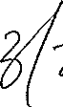

MINI F POLICE BH CELE,

