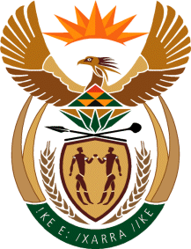

MINISTER IN THE PRESIDENCY: REPUBLIC OF SOUTH AFRICA
Private Bag X1000, Pretoria, 0001, Union Buildings, Government Avenue, PRETORIA
Tel: (012) 300 5200, Website: www.thepresidency.gov.za

NATIONAL ASSEMBLY

WRITTEN QUESTION FOR WRITTEN REPLY

QUESTION NUMBER: 1499

DATE OF PUBLICATIONS: 24 July 2020

1499. Mr C MacKenzie (DA) to ask the Minister in The Presidency [Interdepartmental transfer from the Minister of Communications with effect 24 July 2020]:
Whether he has held any discussions regarding potential candidates to be considered for appointment to the Board of the Media Development and Diversity Agency; if not, what is the position in this regard; if so, (a) with whom and (b) what are the relevant details of each discussion he has held?

REPLY:

No, the Minister in the Presidency has not held any discussions regarding the potential candidates to be considered for appointment to the Board of the Media Development and Diversity Agency.

