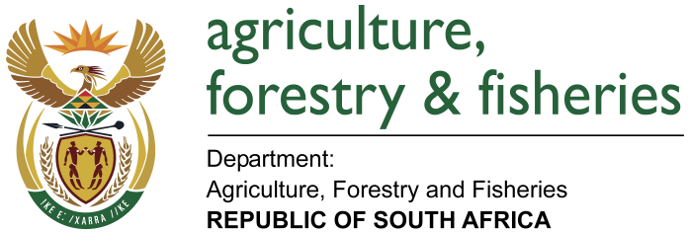
NATIONAL ASSEMBLY

WRITTEN REPLY

QUESTION 1498 / NW 1634E

MINISTER OF AGRICULTURE, FORESTRY AND FISHERIES:
Dr P J Groenewald (FF Plus) to ask the Minister of Agriculture, Forestry and Fisheries:

QUESTION:
(1) (a)(i) How many cases of alleged illegal abalone poaching were reported to his department in each year during the period 1 January 2013 up to the latest specified date for which information is available and (ii) what quantity of abalone was confiscated by his department in each specified year and (b) what happened to the confiscated abalone;
(2) (a) how many (i) persons were arrested in each specified year in this regard and (ii) of the specified arrests were successfully prosecuted and (b) what did the sentence amount to in each case;
(3) whether any of the confiscated abalone was sold; if so, (a) in which way was it sold, (b) who bought it, (c) what were the proceeds from the sales and (d) how were the proceeds spent;
(4) what measures were instituted to curb the illegal poaching of abalone and other marine resources;
(5) whether he will make a statement on the matter? NW 1634E

REPLY:
(1)(a)(i) There are more than nine hundred and six (906) case dockets that have been opened for Abalone-related cases since January 2012.
(1)(a)(ii) The amount of abalone confiiscated since the 2012/13 Financial Year amouts to approximately one hundred and seventy three thousand two hundred and ninety one kilograms (173 291 Kg)
(1)(b) Confiscated abalone is kept in the DAFF stores and samples are retained to be used as evidence in criminal cases. Some of the abalone is also used in under-cover operations.
(2) More than two thousand three hundred and two (2302) suspects have been arrested since 2012. Abalone poaching is a criminal offence. Criminal offences are investigated by the South African Police Services (SAPS) and prosecutions are performed by the National Prosecuting Authority, working together with the SAPS Investigating Officers. Information for prosecution of cases and the sentences imposed can therefore be requested from the Natinational Prosecuting Authority (NPA) since criminal prosecutions are their exclusive mandate.
(3) Yes, confiscated abalone was sold.

(3)(a) Confiscated abalone is always sold through an open auction process.

(3)(b) Abalone Right holders with valid permits to operate Fish Processing Establishments qualify to participate in the auction processes.

(3)(c) The proceeds from the sales of confiscated abalone amounts to R22.266m.

(3)(d) Proceeds from the sale of confiscated abalone were channelled into the Marine Living Resources Fund and were used to support the operations of the various Fisheries Programmes which include Fisheries Operations Support, Aquaculture and Economic Development, Marine Resources Management, Fisheries Research Support, Monitoring Control and Surveillance.

(4) Illegal Unreported and Unregulated (IUU) fishing of Marine resources is a global problem. DAFF is working together with the organised international community in endeavours to address this challenge. South Africa has recently acceded to the Food and Agricultural Orgnaisation’s (FAO) Port State Measures Agreement. The fundamental objective of the Port State Measures Agreement is to mobilise international communities to work together in addressing IUU fishing. The efforts to curb IUU on the domestic front requires inter-departmental and multi-discipinary innitiates. The implementation of Operation Phakisa (Ocean’s Economy) has provided an improved platform for all relevant law enforcement agencies to work together in curbing Abalone poaching. DAFF therefore works together with the other relevant law enforcement agencies, including but not limitted to, the South African Police Services, Department of Environmental Affairs, and South African National Parks.

(5) The Minister’s Budget Vote of 16 May 2018 contained several statements on the ablaone issue, including proposed future approaches to dealing with abalone poaching and the handling of confiscated abalone.

