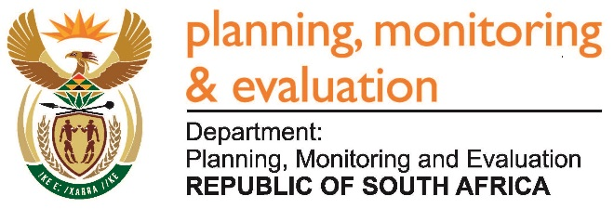 |  | 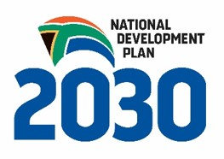
Private Bag X944, PRETORIA, 0001. Union Buildings East Wing, Government Avenue, PRETORIA
Tel: 012 312 0307. www.dpme.gov.za
1496. Mr B S Masango (DA) to ask the Minister in the Presidency:

Whether (a) his Office and (b) each entity reporting to him procured any services from and/or made any payments to (i) a certain company (Bell Pottinger)) or (ii) any other public relations firms; if not, in each case, why not; if so, in each case, what (aa) services were procured, (bb) was the total cost, (cc) is the detailed breakdown of such costs, (dd) was the total amount paid, (ee) was the purpose of the payments and (ff) is the detailed breakdown of such payments? NW1638E

REPLY:

No.

