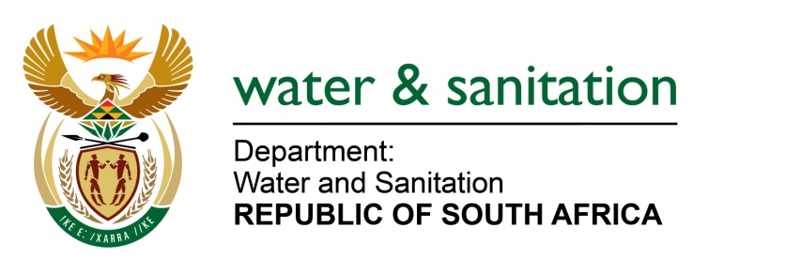

NATIONAL ASSEMBLY

FOR WRITTEN REPLY

QUESTION NO 1462

DATE OF PUBLICATION IN INTERNAL QUESTION PAPER: 17 APRIL 2015
(INTERNAL QUESTION PAPER NO. 10)
1462. Mr T C R Walters (DA) to ask the Minister of Water and Sanitation:
(a) How many invoices from private contractors to her department currently remain unpaid for longer than 30 days and (b) in each case, what (i) are the details of the (aa) contractor and (bb) services provided and (ii) what is the (aa) date of the invoice and (bb) reason why the invoice was not paid within 30 days? NW1675E
---00O00---
REPLY:

- The Department currently has a total 984 invoices from private contractors that are unpaid for longer than 30 days.

- Refer to the attached Annexure A for a detailed list.
---00O00---

