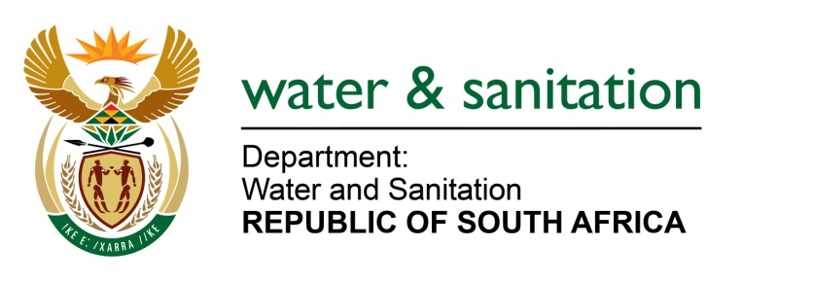

NATIONAL ASSEMBLY

FOR WRITTEN REPLY

QUESTION NO 1490

DATE OF PUBLICATION IN INTERNAL QUESTION PAPER: 05 MAY 2023
(INTERNAL QUESTION PAPER NO. 15)

1490. Mrs M R Mohlala (EFF) to ask the Minister of Water and Sanitation:
What is the current update regarding the completion of the Giyani Water Project, specifically in terms of the reticulation of water to reservoirs and households of the 55 villages? NW1723E
---00O00---
MINISTER OF WATER AND SANITATION
The Giyani Water Project comprises of three different but interlinked projects namely Nandoni-Nsami Pipeline (Giyani Water Project); Giyani Water Services (reticulation to reservoirs) and Reticulation to 55 villages.

The overall progress for the Nandoni-Nsami Pipeline (Giyani Water) Project is 72%. The 40 km pipeline has been completed. The remaining work includes permanent river crossings, chambers, and pressure testing. Water is being pumped from the Nandoni Dam to the canal at Xixukwana and gravitates to the balancing dam at the Nsami Water Treatment Works. Practical completion for Nandoni to Nsami pipeline was achieved on 05 April 2023. The final completion is anticipated for 30 June 2023.

The overall progress for the Giyani Water Services (reticulation to reservoirs) Project is at 60% with 300km of the 325km pipeline installed. Of the 66 planned connections to the reservoirs, 20 (30,3%) have been completed and are supplying bulk water to the community. However, water is currently supplied on rationing basis due to reduced capacity at Nsami WTW. This is being addressed through refurbishment project for the WTW which is currently under construction. Completion of the project is planned for December 2023.

The Giyani reticulation programme was initiated to complete the water service value chain (source to tap) in August 2022. The reticulation program extends the supply from bulk pipelines to households. The reticulation project will be implemented in two phases.
- Phase 1 for reticulation to 24 villages has commenced. A total of 24 out of 37 contractors have been appointed and are at varying stages of implementation phase. The duration of each contract is for 12 months per village.
  - Phase 2 for reticulation to 31 villages is planned for commencement and completion in the 2024/25 financial year.

---00O00---

