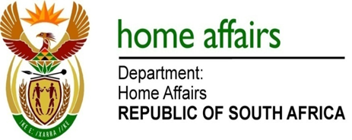

NATIONAL ASSEMBLY

QUESTION FOR WRITTEN REPLY

QUESTION NO. 1490

DATE OF PUBLICATION: Friday, 26 May 2017

INTERNAL QUESTION PAPER 18 OF 2017

1490. Mr T R Majola (DA) to ask the Minister of Home Affairs:

Whether (a) her department and (b) each entity reporting to her procured any services from and/or made any payments to (i) a certain company (name furnished) or (ii) any other public relations firms; if not, in each case, why not; if so, in each case, what (aa) services were procured, (bb) was the total cost, (cc) is the detailed breakdown of such costs, (dd) was the total amount paid, (ee) was the purpose of the payments and (ff) is the detailed breakdown of such payments? NW1632E

REPLY:

The Department and the entities responded as follows:

- Department of Home Affairs
- No, there was no need for such services
- No, there was no need for such services.
- Not applicable
- Not applicable
- Not applicable
- Not applicable
- Not applicable
- Not applicable

(b) Government Printing Works
(i) No, there was no need for such services.
(ii) No, there was no need for such services.
(aa) Not applicable
(bb) Not applicable
(cc) Not applicable
(dd) Not applicable
(ee) Not applicable
(ff) Not applicable

(b) Electoral Commission
(i) No, there was no need for such services.
(ii) No, there was no need for such services.
(aa) Not applicable
(bb) Not applicable
(cc) Not applicable
(dd) Not applicable
(ee) Not applicable
(ff) Not applicable

