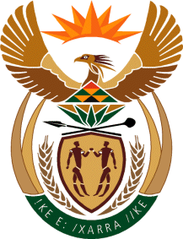

MINISTRY: COMMUNICATIONS
REPUBLIC OF SOUTH AFRICA
Private Bag X 745, Pretoria, 0001, Tel: +27 12 473 0164 Fax: +27 12 473 0585
Tshedimosetso House,1035 Francis Baard Street, Tshedimosetso House, Pretoria, 1000

NATIONAL ASSEMBLY
QUESTION FOR WRITTEN REPLY
QUESTION NUMBER: 1490
DATE: MAY 2016

Ms P T van Damme (DA) to ask the Minister of Communications:
What is the anticipated loss in revenue for the SA Broadcasting Corporation as a result of its decision to ban (a) alcohol, (b) fast-food and (c) children-targeted advertisements? NW1659E

REPLY: THE MINISTER OF COMMUNICATIONS
The existing ASA Code already imposes specific limitations on advertising and sponsorship to which children will be exposed. In terms of alcohol and fast food, the quantification for alcohol was done some years ago and because of the "vagueness" of the fast food proposal, the potential impact on the SABC could not be quantified.

MR NN MUNZHELELE
DIRECTOR GENERAL [ACTING]
DEPARTMENT OF COMMUNICATIONS
DATE:

MS AF MUTHAMBI (MP)
MINISTER OF COMMUNICATIONS
DATE:

