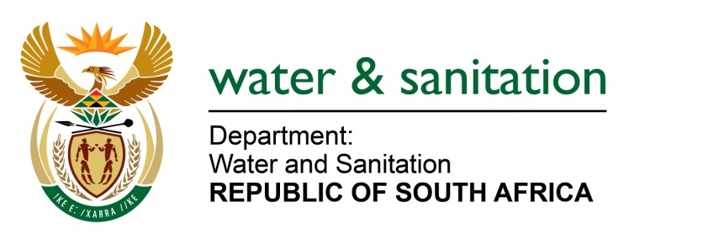

NATIONAL ASSEMBLY

FOR WRITTEN REPLY

QUESTION NO 1489

DATE OF PUBLICATION IN INTERNAL QUESTION PAPER: 05 MAY 2023
(INTERNAL QUESTION PAPER NO. 15)

1489. Mrs M R Mohlala (EFF) to ask the Minister of Water and Sanitation:
What measures has his department taken to address the challenge of boreholes that were drilled in the Mopani District Municipality, but that are non-operational because they have not been powered by Eskom? NW1722E
---00O00---
MINISTER OF WATER AND SANITATION

The Mopani District Municipality has the responsibility of developing and maintaining water and sanitation services infrastructure within its area of jurisdiction as a Water Service Authority (WSA). The Department of Water and Sanitation is supporting the Municipality through various programmes to ensure infrastructure is developed for the efficient provision of water services to communities. This support is provided through the Regional Bulk Infrastructure Grant (RBIG) and Water Services Infrastructure Grant (WSIG) for groundwater development (drilling, equipping and distribution) to augment water supply to communities in Mopani DM.

---00O00---

