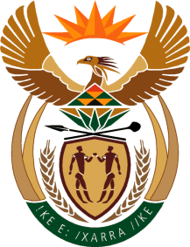

MINISTRY OF TOURISM
REPUBLIC OF SOUTH AFRICA

Private Bag X424, Pretoria, 0001, South Africa. Tel. (+27 12) 444 6780, Fax (+27 12) 444 7027
Private Bag X9154, Cape Town, 8000, South Africa. Tel. (+27 21) 469 5800, Fax: (+27 21) 465 3216

NATIONAL ASSEMBLY:
QUESTION FOR WRITTEN REPLY:
Question Number: 1488
Date of Publication: 21 May 2021
NA IQP Number: 14
Date of reply: 29 May 2021

Ms T M Mbabama (DA) to ask the Minister of Tourism:
(1) Whether her department has concluded any work exchange and/or employment agreements with any entity of the Republic of Cuba from the 2010-11 financial year up to the 2020-21 financial year; if not, what is the position in this regard; if so, what (a) total number of Cuban nationals (i) have been employed in each of the specified financial years and/or (ii) are due to be employed in the 2021-23 Medium-Term Expenditure Framework period, (b) are the details of the work that each of the specified Cuban nationals was and/or will be employed to perform, (c) are the details of the specific skills sets that each of the specified Cuban nationals possessed and/or will possess that South African nationals did or will not possess and (d) are the details of the total cost of employing each of the specified Cuban nationals in each case;
(2) whether her department took any steps to ensure that the specific skills set of the specified Cuban nationals were and/or will not be available in the Republic amongst South African citizens; if not, in each case, why not; if so, what are the relevant details of the (a) steps taken and (b) outcomes of the steps taken in this regard? NW1694E

REPLY:
- The department has not concluded any work exchange and/or employment agreements with any entity of the Republic of Cuba from the 2010-11 financial year up to the 2020-21 financial year;
(a)–(d) Not Applicable

- (a) – (b) Not Applicable

