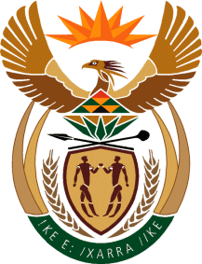

MINISTRY OF TOURISM
REPUBLIC OF SOUTH AFRICA

Private Bag X424, Pretoria, 0001, South Africa. Tel. (+27 12) 444 6780, Fax (+27 12) 444 7027
Private Bag X9154, Cape Town, 8000, South Africa. Tel. (+27 21) 469 5800, Fax: (+27 21) 465 3216

Ref: TM 2/1/1/10
QUESTION FOR WRITTEN REPLY:
Question Number: 1488
Date of Publication: 11 May 2018
NA IQP Number: 15
Date of reply: 23 May 2018
Mr I M Ollis (DA) to ask the Minister of Tourism:
(1) Whether, with reference to the reply of the President, Mr C M Ramaphosa, to the debate on the State of the Nation Address on 22 February 2018 to implement lifestyle audits, (a) he, (b) senior management service members in his department and/or (c) any of the heads of entities reporting to him have undergone a lifestyle audit in the past three financial years; if not, have any plans been put in place to perform such audits; if so, in each case, what are the details of the (i) date of the lifestyle audit, (ii) name of the person undergoing the audit, (iii) name of the auditing firm conducting the audit and (iv) outcome of the audit;
(2) Whether he will furnish Mr I M Ollis with copies of the lifestyle audit reports? NW1591E
Reply:

- Implementation of lifestyle audits the past three financial years:

No, the Department and its entity (SAT) has not performed any lifestyle audits in the past three financial years.

If not, have any plans put in place to perform such audits:

No, the Department and its entity (SAT) has not developed any plans to conduct such audits in this financial year.

If so what is the detail? Not applicable
- Date of the lifestyle audit: Not applicable
(ii) Name of person undergoing the audit: Not applicable
(iii) Name of the audit firm: Not applicable
(iv) Outcome of the audit Not applicable

(2). Whether he will furnish Mr I M Ollis with copies of the lifestyle audit reports? Not Applicable.

