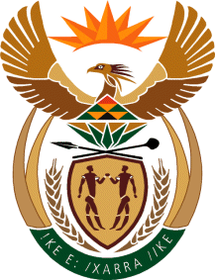

MINISTRY: COMMUNICATIONS
REPUBLIC OF SOUTH AFRICA
Private Bag X 745, Pretoria, 0001, Tel: +27 12 473 0164 Fax: +27 12 473 0585
Tshedimosetso House,1035 Francis Baard Street, Tshedimosetso House, Pretoria, 1000

NATIONAL ASSEMBLY
QUESTION FOR WRITTEN REPLY
QUESTION NUMBER: 1488
DATE: MAY 2016

Ms P T van Damme (DA) to ask the Minister of Communications:
(a) Which SA Broadcasting Corporation (i) TV channels and (ii) radio stations received advertising revenue from (aa) municipalities and (bb)(aaa) national and (bbb) provincial government departments in the 2015-16 financial year, (b) what was the purpose of each advertising campaign, (c) on which (i) TV channel and (ii) radio station was each specified campaign broadcast and (d) what was the total revenue generated in each specified case? NW1657E

REPLY: MINISTER OF COMMUNICATIONS

(a) (i) TV revenue is R39 million.
(ii) Radio Revenue is R277 million.
(b), (c) & (d)
All these were initiatives to promote services provided by the respective departments and municipalities. These were campaigns to create awareness about services the respective departments provide to the nation.

MR NN MUNZHELELE
DIRECTOR GENERAL [ACTING]
DEPARTMENT OF COMMUNICATIONS
DATE:

MS AF MUTHAMBI (MP)
MINISTER OF COMMUNICATIONS
DATE:

