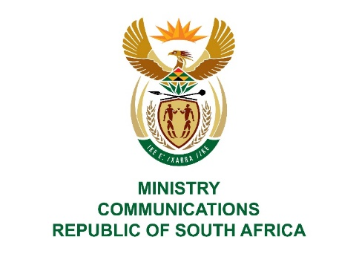
Private Bag X860, Pretoria, 0001, Tel: +27 12 427 8270 Fax: +27 12 427 8115
Private Bag X 9151, Cape Town, 8000 Tel: +27 21 469 5223 Fax: +27 21 462 1646
URL: http://www.dtps.gov.za

NATIONAL ASSEMBLY

QUESTION FOR WRITTEN REPLY

QUESTION NO: 1487

1487. Mr T W Mhlongo (DA) to ask the Minister of Communications:
(1) Is the SA Broadcasting Corporation (SABC) broadcasting on or licensing drama series or parts thereof to YouTube and other electronic media platforms such as ShowMax; if so, what (a) is the name of each programme affected, (b) amount is received from each transaction and (c) individual share of profit is due to each producer, writer and performer for each transaction;
(2) on what date will the SABC pay the relevant profit share fees to each producer, writer and performer? NW2755E
REPLY
I have been advised by the SA Broadcasting Corporation as follows:
- Yes, the SABC broadcasts on You Tube, Show Max and Vu.
  - See attachment, titled, Media platforms the SABC broadcast on. It details each programme name.

  - See attachment, titled, Media platforms the SABC broadcast on. The attachment details the amounts received by the SABC for each programme sold.

  - Commercial exploitation fees and profit share are used interchangeably. When we refer to profit share we normally mean commercial exploitation fees. Yes commercial exploitation fees are paid to the Producer, the Writer and the Principal Performers in licensed programmes. The Producer might be paid a further 10% of the commercial exploitation fee where the Producer facilitated the licensing of the programme.

- Payments are made on a continuous basis based on each agreement. The royalty payments / profit share payments were allocated for payment at the end of October 2019 after receiving the first portion of the bailout.

MS. STELLA NDABENI-ABRAHAMS, MP
MINISTER

