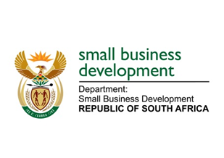
NATIONAL ASSEMBLY
QUESTION FOR WRITTEN REPLY
DUE TO PARLIAMENT: FRIDAY, 4 JUNE 2021

“1485. Mr G G McGluwa (DA) to ask the Minister of Small Business Development:

(1) Whether her department has concluded any work exchange and/or employment agreements with any entity of the Republic of Cuba from the 2010-11 financial year up to the 2020-21 financial year; if not, what is the position in this regard; if so, what (a) total number of Cuban nationals (i) have been employed in each of the specified financial years and/or (ii) are due to be employed in the 2021-23 Medium-Term Expenditure Framework period, (b) are the details of the work that each of the specified Cuban nationals was and/or will be employed to perform, (c) are the details of the specific skills sets that each of the specified Cuban nationals possessed and/or will possess that South African nationals did or will not possess and (d) are the details of the total cost of employing each of the specified Cuban nationals in each case;
(2) whether her department took any steps to ensure that the specific skills set of the specified Cuban nationals were and/or will not be available in the Republic amongst South African citizens; if not, in each case, why not; if so, what are the relevant details of the (a) steps taken and (b) outcomes of the steps taken in this regard? NW1691E
_______________________________________________________________________________

RESPONSE:

The Department of Small Business Development (DSBD) did not have any work exchange programme with the Republic of Cuba and has not employed any Cuban Nationals. There are no plans in the pipeline in this regard.
- Not applicable.
- Not applicable.

_________________________________________________________________________________
RESPONSE RECOMMENDED BY:

_______________________
MR LINDOKUHLE MKHUMANE
DIRECTOR GENERAL: DEPARTMENT OF SMALL BUSINESS DEVELOPMENT
DATE:
______________________________________________________________________________

RESPONSE RECOMMENDED BY:

________________________
MS ROSEMARY CAPA, MP
DEPUTY MINISTER OF SMALL BUSINESS DEVELOPMENT
DATE:

_______________________________________________________________________________
RESPONSE APPROVED BY:

_________________________
MS KHUMBUDZO NTSHAVHENI, MP
MINISTER FOR SMALL BUSINESS DEVELOPMENT
DATE:

