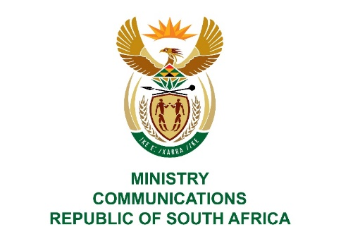
Private Bag X860, Pretoria, 0001, Tel: +27 12 427 8270 Fax: +27 12 427 8115
Private Bag X 9151, Cape Town, 8000 Tel: +27 21 469 5223 Fax: +27 21 462 1646
URL: http://www.dtps.gov.za

NATIONAL ASSEMBLY

QUESTION FOR WRITTEN REPLY

QUESTION NO: 1485

1485. Mr. Z N Mbhele (DA) to ask the Minister of Communications:
(1) Whether the SA Broadcasting Corporation (SABC) will supply a list of (a) programmes licenced to KykNet up to the latest specified date for which information is available, (b) the fees attached to each transaction and (c) individual share of profit due to each of the (i) producers, (ii) writers and (iii) performers for each transaction;
(2) On what date will the SABC (a) honour their contracts and (b) pay the share of the profit of commercial exploitations to the producers, writers and performers for each transaction;
(3) whether the SABC will be paying interest for late payment considering that the share in profit due to producers, writers and performers is by contract and should have been paid bi-annually; if not, what is the position in this regard; if so, what are the further relevant details? NW2753E
REPLY
I have been advised by the SA Broadcasting Corporation as follows:
- (a) (b) (c) A list of 78 titles have been licenced to Kyknet, as detailed in the attached spreadsheet and the fees received for all titles licenced is included therein. It further indicates the profit share where applicable.

(a) Contracts for licensed content from 2014-2018 have been honoured in line with the applicable SOP. Content contracts for 1996 – 2014 are still to be processed. The date is to be determined.
(b) Profit / commercial exploitation payments for licensed content from 2014-2018 have been made. Payments for the years 1996- 2014 are still to be processed and the date thereof to be determined.

- The SABC does not pay interests on late payment of commercial exploitation fees. Payment of interest must be negotiated with the SABC.

MS. STELLA NDABENI-ABRAHAMS, MP
MINISTER

