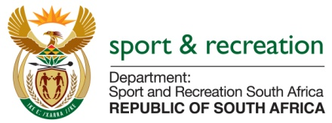

NCOP QUESTION FOR THE MINISTER

QUESTION 1485 (NW1588E) FOR WRITTEN REPLY

Mr. RK PURDOK (DA) to ask the Minister of Sport and Recreation:

- Whether, with reference to the reply of the President, Mr C. Ramaphosa, to the debate on the state of the Nation Address on 22 February 2018 to implement lifestyle audits, (a) she, (b) senior management services members in her department and/or (c) any of the heads of entities reporting to her have undergone a lifestyle audit in the past three financial years; if not, have any plans been put in place to perform such audits; if so, in each case, what are the details of the (i) date of the lifestyle audit, (ii) name of the person undergoing the audit, (iii) name of the auditing firm conducting the audit and (iv) outcome of the audit?

- Whether she will furnish Mr. RK Purdok with copies of the lifestyle audit reports?

(NW1588E)

REPLY

Minister Xasa fully supports the call by President Ramaphosa, for the public service to institute a lifestyle audit mechanism to monitor the lifestyles of personnel in the public service, especially the members of SMS and other senior people in the service of the public, including personnel at the leadership of state entities.

To this end, the Minister has noted the question from the Honourable Purdon (MPL), in relation to lifestyle audits. However, to date, the Minister has not found cause to institute any audits on the lifestyles of any personnel in the Ministry and neither is there cause to institute any such audits on the heads of entities, at this stage.

MS T. XASA, MP
MINISTER OF SPORT AND RECREATION SA

