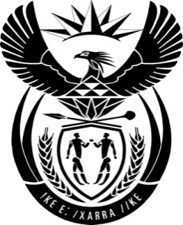

THE PRESIDENCY: REPUBLIC OF SOUTH AFRICA
Private Bag X1000, Pretoria, 0001
NATIONAL ASSEMBLY
QUESTIONS FOR WRITTEN REPLY

QUESTION NO: 1484

Date Published: 11 April 2016

Mr M Waters (DA) to ask the President of the Republic:
(1) Whether he (a) enquired, (b) planned and/or (c) partook in any discussions regarding the alleged activities of security services regarding the (i) Association of Mineworkers and Construction Union and the establishment of the Workers’ Association Union and/or (ii) collection of evidence relating to the mandate of the Seriti Commission by the Special Operations Unit in Europe following the establishment of the specified commission (details furnished); if not, what is the position in this regard; if so, (aa) in which way and (bb) to what extent was he involved in this regard;

(2) Whether (a) he and/or (b) The Presidency received a report from the Special Operations Unit relating to evidence to be collected pertaining to the Seriti Commission; if so, what are the relevant details?

Reply:
The matters referred to in the question are subject of litigation before the courts of law. As such, I am not in a position at this stage to reply to the question.

