|  |
| --- |
| image1 |
| **MINISTRY OF COMMUNICATIONS REPUBLIC OF SOUTH AFRICA**  Private Bag X 745, Pretoria, 0001, Tel: +27 12 473 0164 Fax: +27 12 473 0585  Tshedimosetso House,1035 Francis Baard Street, Tshedimosetso House, Pretoria, 1000 |

**NATIONAL ASSEMBLY**

**QUESTION FOR WRITTEN REPLY**

**QUESTION NO: 1482**

**1482. Mrs V van Dyk (DA) to ask the Minister of Communications:**

Why does the SA Broadcasting Corporation (SABC) apply clause 7.2.2. of the SABC Freelance Contract, which offers the principal performers 2% of the profit to be shared amongst them, and ignore clause 7.2.1 which requires the SABC and the principal performers to first endeavour to agree on a lump sum amount before applying clause 7.2.2? NW2750E

**REPLY**

I have been advised by the department as follows:

There are two reasons why the SABC applies clause 7.2.2

1. The SABC is not forced to (or must) negotiate a lump sum in terms of clause 7.2.1. It is merely an option available to the SABC. The SABC therefore prefers to opt for clause 7.2.2 which refers to the 2% profit share.
2. It also becomes practically impossible and a protracted process to negotiate individually with the performers once the SABC has commercialized a production. Therefore, the implementation of clause 7.2.2 is applicable, see below.

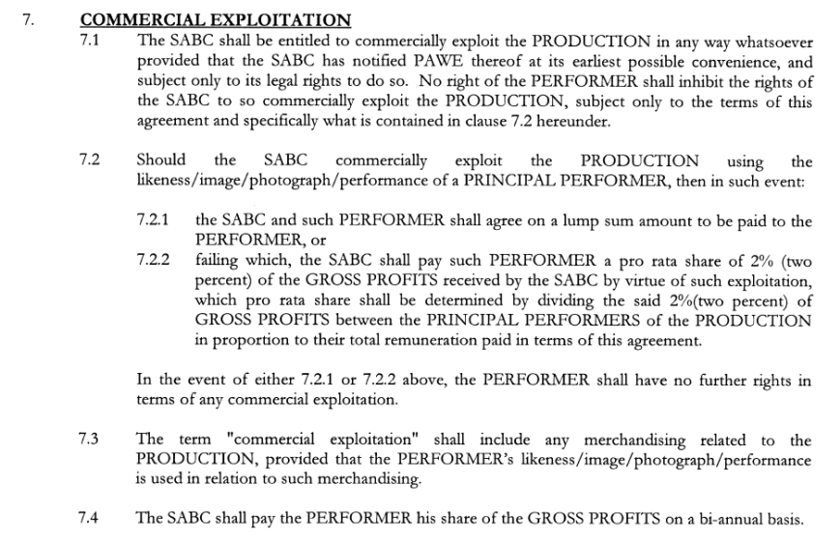

**MS. STELLA NDABENI-ABRAHAMS**

**MINISTER**