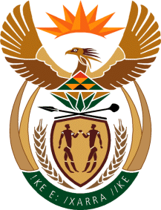

MINISTER IN THE PRESIDENCY: REPUBLIC OF SOUTH AFRICA
Private Bag X1000, Pretoria, 0001, Union Buildings, Government Avenue, PRETORIA
Tel: (012) 300 5200, Website: www.thepresidency.gov.za

NATIONAL ASSEMBLY
WRITTEN QUESTION FOR WRITTEN REPLY

QUESTION NUMBER: 1481
DATE OF PUBLICATIONS: 21 May 2021

1481. Mr L Mphithi (DA) to ask the Acting Minister in The Presidency:
(1) Whether her Office has concluded any work exchange and/or employment agreements with any entity of the Republic of Cuba from the 2010-11 financial year up to the 2020-21 financial year; if not, what is the position in this regard; if so, what (a) total number of Cuban nationals (i) have been employed in each of the specified financial years and/or (ii) are due to be employed in the 2021-23 Medium-Term Expenditure Framework period, (b) are the details of the work that each of the specified Cuban nationals was and/or will be employed to perform, (c) are the details of the specific skills sets that each of the specified Cuban nationals possessed and/or will possess that South African nationals did or will not possess and (d) are the details of the total cost of employing each of the specified Cuban nationals in each case;
(2) whether her Office took any steps to ensure that the specific skills set of the specified Cuban nationals were and/or will not be available in the Republic amongst South African citizens; if not, in each case, why not; if so, what are the relevant details of the (a) steps taken and (b) outcomes of the steps taken in this regard? NW1686E.

REPLY:
- Department of Planning, Monitoring and Evaluation has not concluded any work exchange and/or employment agreements with any entity of the Republic of Cuba and/or Cuban National from 2010 – 2011 financial year up to the 2020 – 2021 financial year.
- The Presidency has not concluded any work exchange and/or employment agreements with any entity of the Republic of Cuba and/or Cuban National from 2010 – 2011 financial year up to the 2020 – 2021 financial year.

Thank You.

