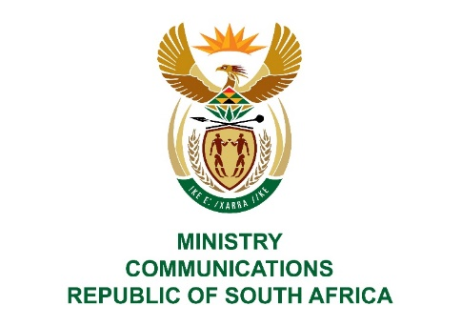
Private Bag X860, Pretoria, 0001, Tel: +27 12 427 8270 Fax: +27 12 427 8115
Private Bag X 9151, Cape Town, 8000 Tel: +27 21 469 5223 Fax: +27 21 462 1646
URL: http://www.dtps.gov.za
___________________________________________________________

NATIONAL ASSEMBLY

QUESTION FOR WRITTEN REPLY

QUESTION NO: 148

148. Mr. C MacKenzie (DA) to ask the Minister of Communications:
(a)(i) On what date and (ii) under what terms was a set-top box testing facility established at the SA Bureau of Standards, (b) what was the cost to her department of establishing this facility and (c) what number of set-top boxes have been tested at the facility since it was completed?NW169E
REPLY
I have been advised by the department as follows:

(a)(i) The SABS decoder testing lab was established in February 2012.
(ii) The lab was established to test decoders to be manufactured in South Africa based on the SANS862 national DTT decoder standard administered by the SABS. A Memorandum of Understanding (MoU) was signed between the Department of Communications (DoC), Department of Trade and Industry [DTI] and the SA Bureau of Standards (SABS). Under the terms of the MoU, the SABS had to:
- Assume responsibility for the establishment and operations of the decoder conformance lab.
- Procure lab test equipment
- Appoint personnel to operate the lab
- Work closely with the DoC and broadcasters on operational matters of the lab as and when necessary.
(b)The SABS was given a once-off grant of R30-million for the establishment of the facility by the DoC under the terms of the MoU, to perform the duties as outlined.
(c) According to the records provided by the SABS, they have tested and issued certificates for eleven (11) decoder samples from a number of local suppliers since the inception of the lab in 2012. The method was to test one decoder sample per model of decoder that the manufacturer was in the process of putting into production. The list of the samples is provided below:
Supplier | DTH-Satellite STB | DTT-Terrestrial STB | Model
ABT | x |  | STB351-SNT-MTC-01
ABT |  | x | STB341-MTC01
African Digitech Solutions (ADS) |  | x | TJ5023U
BUA Africa |  | x | DTD 4N
BUA Africa |  | x | HT8863L
BUA Africa | x |  | HSJ10
BUA Africa |  | x | HS6100
Altech UEC |  | x | DTD 4126
CZ Electronics |  | x | FR9600
Leratadima |  | x | STB341-MTC01
M-Net |  | x | Go-TV

MS. STELLA NDABENI-ABRAHAMS, MP
MINISTER

